

CAPSTONE PROJECT REPORT
Report 4 – Software Design Document

– Cantho, October 2022 –

Table of Contents
Table of Contents 2
I. Project Report 6
1. Status Report 6
2. Team Involvements 6
3. Issues/Suggestions 9
II. Software Design Document 10
1. Overall Description 10
1.1 Assumptions 10
1.2 Design Constraints 10
2. System Architecture Design 11
2.1 Overall Architecture 11
2.2 System Architecture 13
2.3 Package Diagram 14
3. System Detailed Design 16
a. Class Diagram 16
b. Sequence Diagram(s) 17
1. Login 17
2. Logout 18
3. Forgot password 19
4. Create Account 20
5. View Account List 20
6. Update Account 21
7. Deactivate Account 22
8. View deactivated account list 22
9. Create Module 23
10. View Module list 24
11. Update Module 25
12. Delete Module 26
13. Create Class 27
14. View Class List (Academic Department Role) 28
15. Update Class (Academic Department Role) 29
16. Create Final Exam 30
17. View Exam List 31
18. Update Final Exam 32
19. Delete Exam (Academic Department Role) 33
20. View module list 34
21. Create Exam 35
22. View Exam List 36
23. Update Exam 37
24. Delete Exam (Teacher Role) 38
25. Export excel module’s exam results (Teacher Role) 39
26. View exam result, analysis 40
27. Create exam paper 41
28. Grade written questions (Teacher Role) 42
29. View all requests add question bank 43
30. Approve/Reject request to add question 44
31. Request add new question to question bank 45
32. Assign teacher to process add question request 46
33. View exam schedule (Student Role) 47
34. View exam questions 48
35. Submit exam (Student Role) 49
36. Mark report 50
37. View module list by Student 51
38. Invigilate 52
4. Class Specifications 52
4.1 AcademicDepartmentController Class 52
4.1.1 Class Methods 52
4.1.2 Attributes of the Class 52
4.2 AccountController Class 53
4.2.1 Class Methods 53
4.2.2 Attributes of the Class 56
4.3 AnswerController Class 56
4.3.1 Class Methods 56
4.3.2 Attributes of the class 58
4.4 AuthenticationController Class 58
4.4.1 Class Methods 58
4.4.2 Attributes of the Class 61
4.5 CheatController Class 61
4.5.1 Class Methods 61
4.5.2 Attributes of the Class 62
4.6 ClassController Class 62
4.6.1 Class Methods 62
4.6.2 Attributes of the Class 63
4.7 ClassModuleController Class 63
4.7.1 Class Methods 63
4.7.2 Attributes of the class 65
4.8 ExamController Class 66
4.8.1 Class Methods 66
4.8.2 Attributes of the class 71
4.9 ExamQuestionsController Class 71
4.9.1 Class Methods 71
4.9.2 Attributes of the Class 73
4.10 InvigilateController Class 73
4.10.1 Class Methods 73
4.10.2 Attributes of the Class 75
4.11 MarkController Class 75
4.11.1 Class Methods 75
4.11.2 Attributes of the Class 75
4.12 ModuleController Class 76
4.12.1 Class Methods 76
4.12.2 Attributes of the class 78
4.13 NotifyController Class 79
4.13.1 Class Methods 79
4.13.2 Attributes of the class 80
4.14 QuestionController Class 80
4.14.1 Class Methods 80
4.14.2 Attributes of the Class 81
4.15 StudentController Class 81
4.15.1 Class Methods 81
4.15.2 Attributes of the class 84
4.16 TeacherController Class 84
4.6.1 Class Methods 84
4.6.2 Attributes of the Class 84
4.17 TokenController Class 85
4.17.1 Class Methods 85
4.17.2 Attributes of the Class 86
5. Data & Database Design 87
5.1 Database Design 87
a. AcademicDeparment Table 88
b. AddQuestionRequest Table 88
c. Administartor Table 89
d. Answer Table 89
e. CheatingType Table 89
f. ClassModuleStudent Table 89
g. Class Table 90
h. ClassModule Table 90
i. ExamFEQuestion Table 90
j. Exam Table 91
k. ExamQuestion Table 92
m. FEAnswer Table 92
m. FEQuestion Table 93
n. Level Table 93
o. Module Table 93
p. Question Table 94
q. QuestionType Table 94
r. Role Table 94
s. Student Table 95
t. StudentAnswer Table 95
u. StudentCheating Table 96
v. StudentExamInfos Table 96
w. StudentFEAnswer Table 97
x. Teachers Table 97

I. Project Report

1. Status Report
# | Work Item | Status | Notes (Work Item in Details)
1 | Complete Report 4 | Completed

2. Team Involvements
# | Task | Member | Notes (Task Details, etc.)
1 | Project Report | MinhHK
2 | 1. Overall Description | MinhHK
3 | 2.1 Overall Architecture | ThoTA
4 | 2.2 System Architechture | ToanTK
5 | 2.3 Pakage Diagram | KhangTD
6 | 3. System Detailed Design
7 | a. Class Diagram | MinhDN
8 | b. Sequence Diagram
9 | 1. Login | KhangTD
10 | 2. Logout | KhangTD
11 | 3. Forgot password | KhangTD
12 | 4. Create Account | ThoTA
13 | 5. View Account List | ThoTA
14 | 6. Update Account | KhangTD
15 | 7. Delete Account | ThoTA
16 | 8. View deactivated account list | ThoTA
17 | 9. Create Module | MinhDN
18 | 10. View Module list | MinhHK
19 | 11. Update Module | MinhDN
20 | 12. Delete Module | MinhDN
21 | 13. Create Class | KhangTD
22 | 14. View Class List | ToanTK
23 | 15. Update Class | ToanTK
24 | 16. Create Exam | MinhDN
25 | 17. View Exam List | MinhHK
26 | 18. Update Exam | MinhDN
27 | 19. Delete Exam | MinhHK
28 | 20. View module list | MinhDN
29 | 21. Create Exam | MinhDN
30 | 22. View Exam List | MinhDN
31 | 23. Update Exam | MinhDN
32 | 24. Delete Exam | MinhHK
33 | 25. Export excel module’s exam results | ToanTK
34 | 26. View exam result, analysis | MinhHK
35 | 27. Create exam paper | ThoTA
36 | 28. Grade written questions | ToanTK
37 | 29. View request Add question bank | KhangTD
38 | 30. Approve/Reject request to add question | KhangTD
39 | 31. Request add new question to question bank | KhangTD
40 | 32. Assign teacher to process add question request | MinhHK
41 | 33. View exam schedule | ToanTK
42 | 34. View exam questions | KhangTD
43 | 35. Submit exam | ToanTK
44 | 36. Mark report | ThoTA
45 | 37. View module list | ToanTK
46 | 4. Class Specification
47 | 4.1 AcademicDepartmentController Class | ThoTA
48 | 4.2 AccountController Class | KhangTD
49 | 4.3 AnswerController Class | MinhDN
50 | 4.4 AuthenticationController Class | KhangTD
51 | 4.5 CheatController Class | ThoTA
52 | 4.6 ClassController Class | MinhHK
53 | 4.7 ClassModuleController Class | ToanTK
54 | 4.8 ExamController Class | MinhDN
55 | 4.9 ExamQuestionsController Class | ThoTA
56 | 4.10 InvigilateController Class | ThoTA
57 | 4.11 MarkController Class | ThoTA
58 | 4.12 ModuleController Class | ToanTK
59 | 4.13 NotifyController Class | ToanTK
60 | 4.14 QuestionController Class | MinhHK
61 | 4.15 StudentController Class | ToanTK
62 | 4.16 TeacherController Class | MinhHK
63 | 4.17 TokenController Class | KhangTD
64 | 5. Data & Database Design
65 | 5.1 Databasae Design | MinhDN
66 | 5.2 Data File Design
67 | a. AcademicDeparment Table | ToanTK
68 | b. AddQuestionRequest Table | MinhHK
69 | c. Administartor Table | KhangTD
70 | d. Answer | MinhHK
71 | e. CheatingType | ThoTA
72 | f. ClassModuleStudent | KhangTD
73 | g. Class | ThoTA
74 | h. ClassModule Table | MinhHK
75 | i. ExamFEQuestion Table | ToanTK
76 | j. Exam Table | MinhDN
77 | k. ExamQuestion Table | ToanTK
78 | l. FEAnswer Table | MinhDN
79 | m. FEQuestion Table | MinhHK
80 | n. Level Table | ThoTA
81 | o. Module Table | KhangTD
82 | p. Question Table | KhangTD
83 | q. QuestionType Table | MinhDN
84 | r. Role Table | MinhHK
85 | s. Student Table | ThoTA
86 | t. StudentAnswer Table | ToanTK
87 | u. StudentCheating Table | ToanTK
88 | v. StudentExamInfo Table | MinhHK
89 | w. StudentFEAnswer Table | ThoTA
90 | x. Teacher Table | MinhHK

3. Issues/Suggestions
# | Issue | Status | Notes (Solution, Suggestion, etc.)
1

II. Software Design Document

1. Overall Description

1.1 Assumptions
This system is designed basing on these following assumptions:
- Windows 10 or higher
- Microsoft Edge 100, Chrome 100, Coc coc 106
- PostgreSQL
- C# 9.0
- DBeaver 22.2.2
- .NET Core 5.0 Framework
- React 18.2.0
- Python 3.10.70
- Bootstrap 5.0
In our system, users are divided into 5 roles:
- Administrator: are allowed to manage user accounts of the system.
- Academic Department: are responsible for managing class, module, exam,...
- Student: are allowed to take exam, view their mark report.
- Teacher: are responsible for managing their class, create exam,...
- Head of Department: just like role teacher but also are responsible for assigning teacher to execute the add question to the question bank.

1.2 Design Constraints
This system should be complied with following items:
- Work well on Microsoft Edge browser.
- UX/UI fit for desktop and mobile devices.
- The system can be scaled up if needed.
- Most features of the system will take maximum 5 seconds to load.
- Obey network information security laws.

2. System Architecture Design

2.1 Overall Architecture
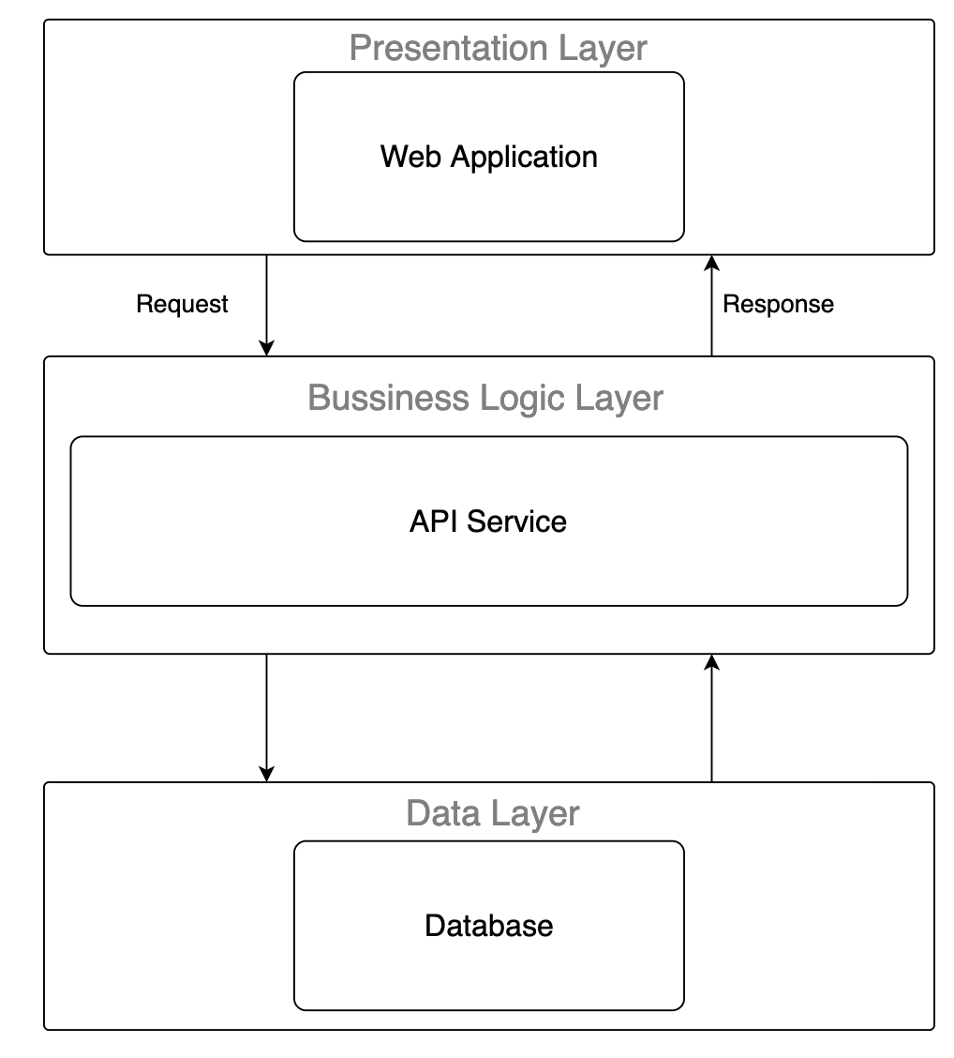
Figure 1 Overall Architecture
The first layer is the presentation layer which can show the user interface, receiving input from the user and performing local validation. Based on the user's action, the Presentation layer will send appropriate HTTP Requests to the Business Logic Layer and display data (or error message) which is HTTP Response sent by the Business Logic Layer.
The second layer is the business logic layer. This layer is responsible for handling the incoming request from the presentation layer, process data which is sent by the Data Layer.
The last layer is the Data Layer which stores all data of the system. This layer only communicates with the Business Logic Layer, perform appropriate action which Business Logic Layer need and have no direct interaction with the Presentation Layer.

2.2 System Architecture
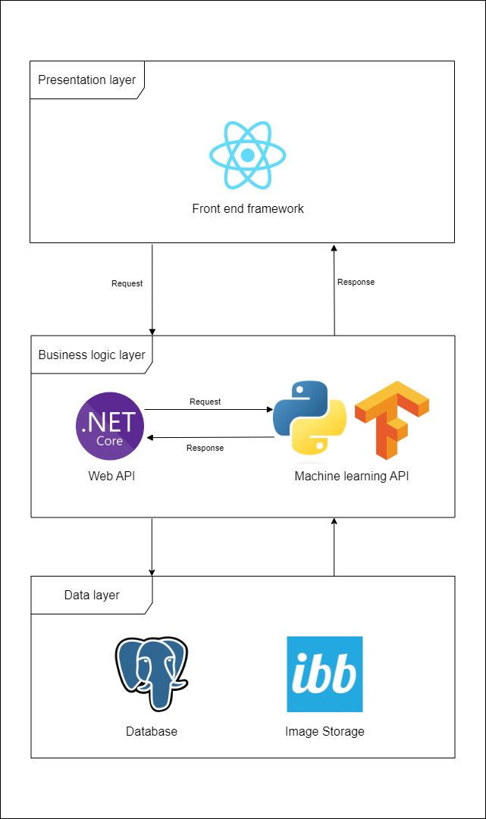
Figure 2 System Architecture

2.3 Package Diagram
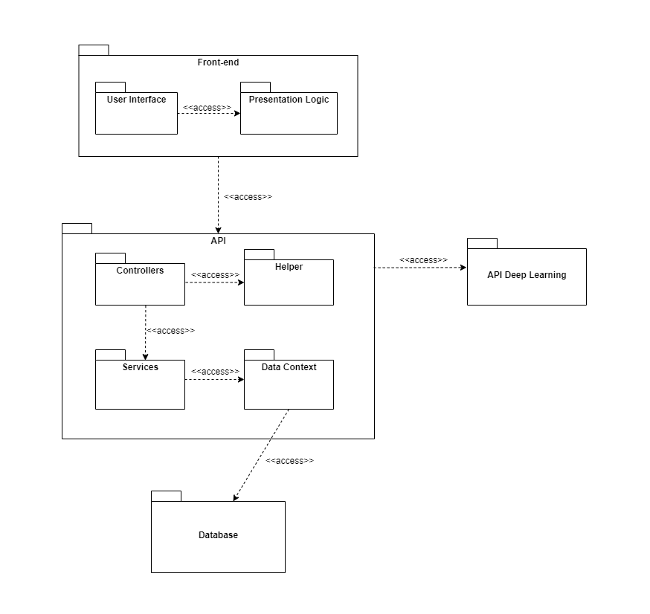
Figure 3 Package Diagram

Code Packages
No | Package | Description
1 | Front-end | Containing the user interface and the programming logic that makes user interface functions
2 | User Interface | Containing all the user interfaces of system
3 | Presentation Logic | Containing all the programming logic that makes user interface functions
4 | API | Containing all packages and classes that handle request and response from front-end
5 | Controllers | Containing all classes that handle the input and output of the API
6 | Services | Containing all packages and classes that handle the business logic of the API
7 | Data Context | Handling getting data into and out of the database
8 | Helper | Containing all packages and classes that handle all the other logic
9 | Database | Containing all datas of the system
10 | API Deep Learning | Containing all deep learning functions that handle the cheating detection

3. System Detailed Design

a. Class Diagram
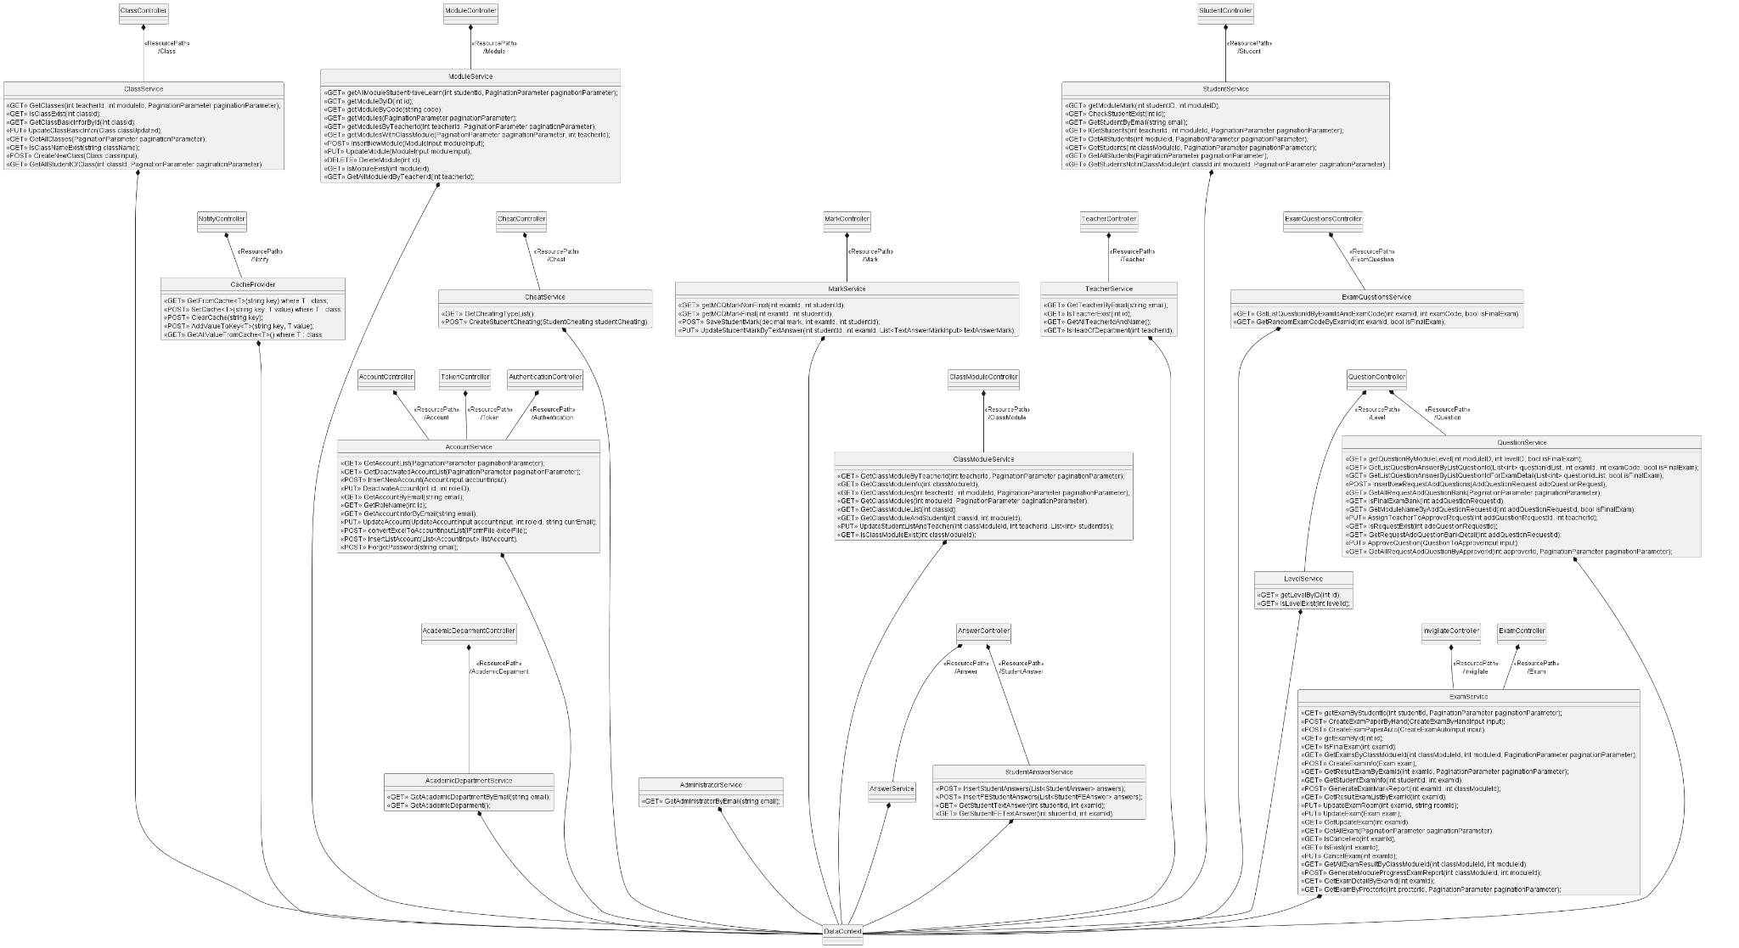
Figure 4 Class Diagram

b. Sequence Diagram(s)

Login
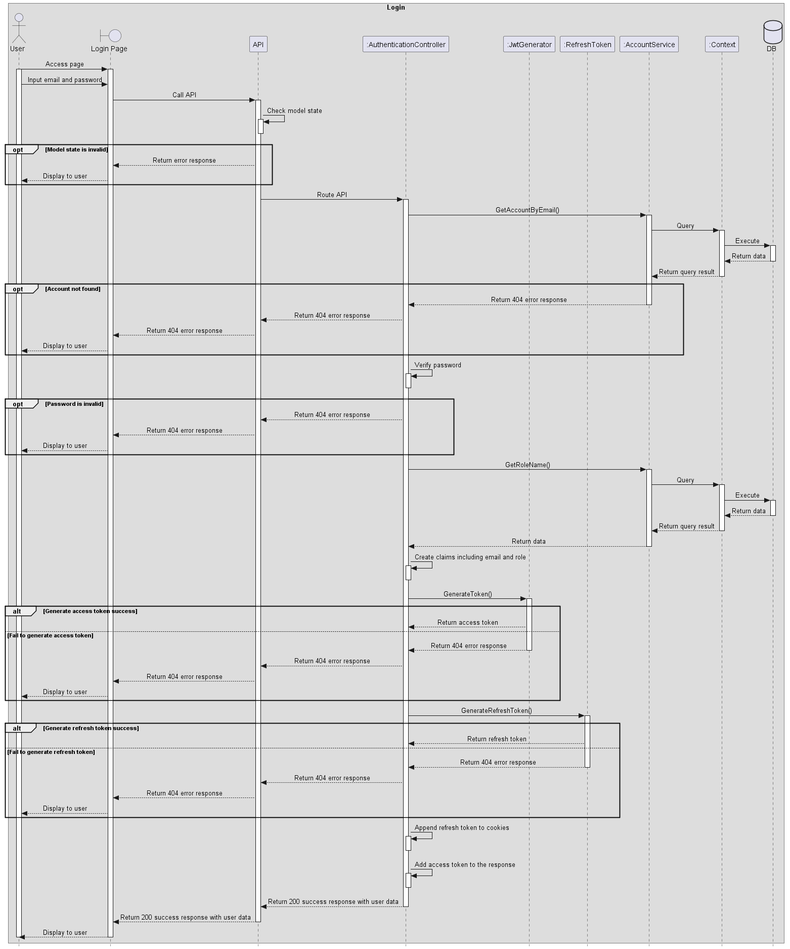
Figure 5 Login

Logout
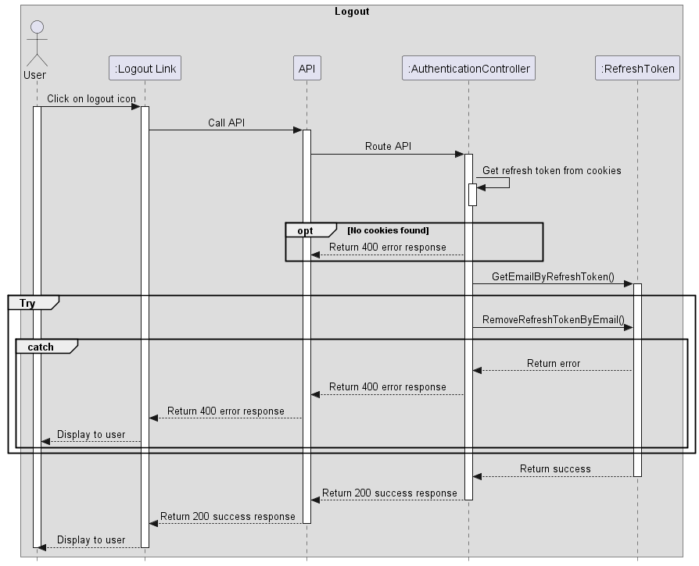
Figure 6 Logout

Forgot password
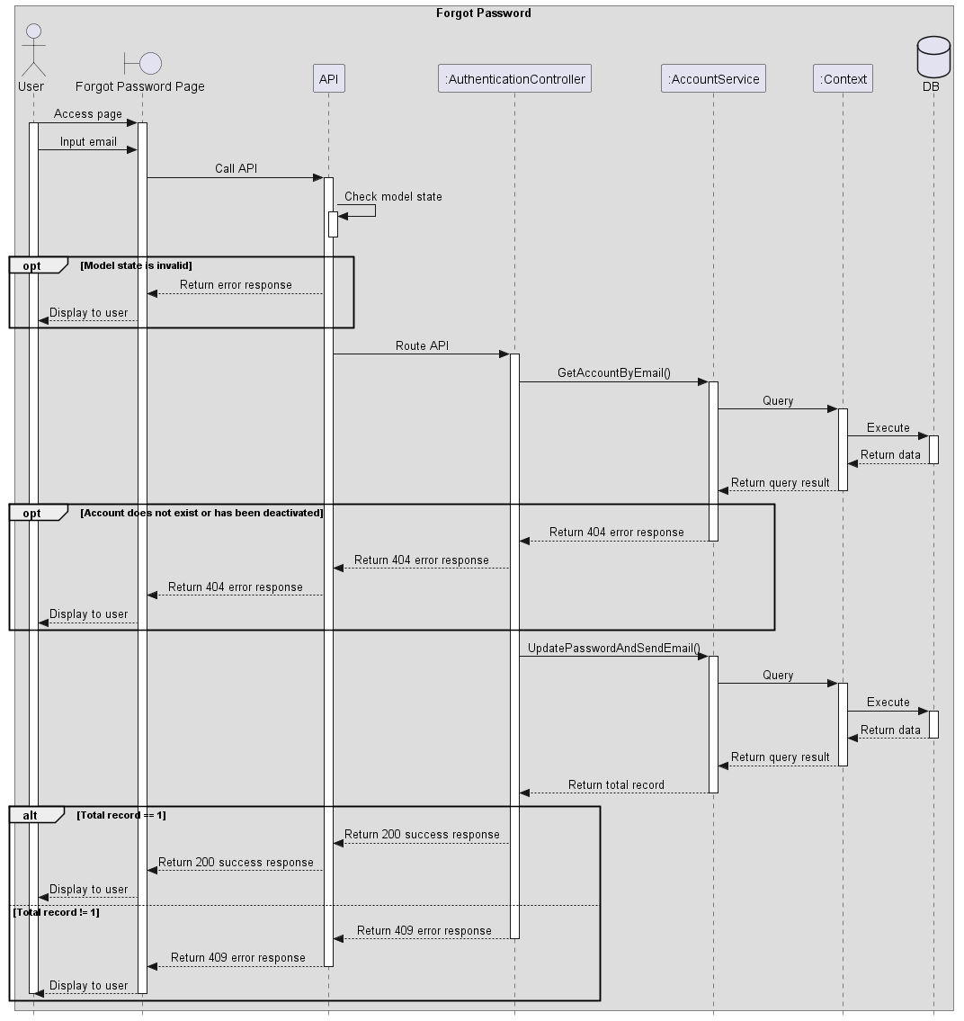
Figure 7 Forgot password

Create Account
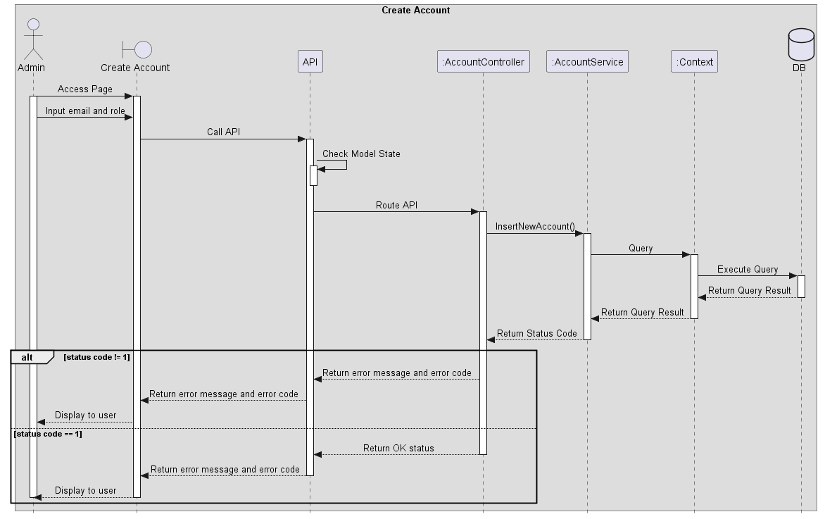
Figure 8 Create Account

View Account List
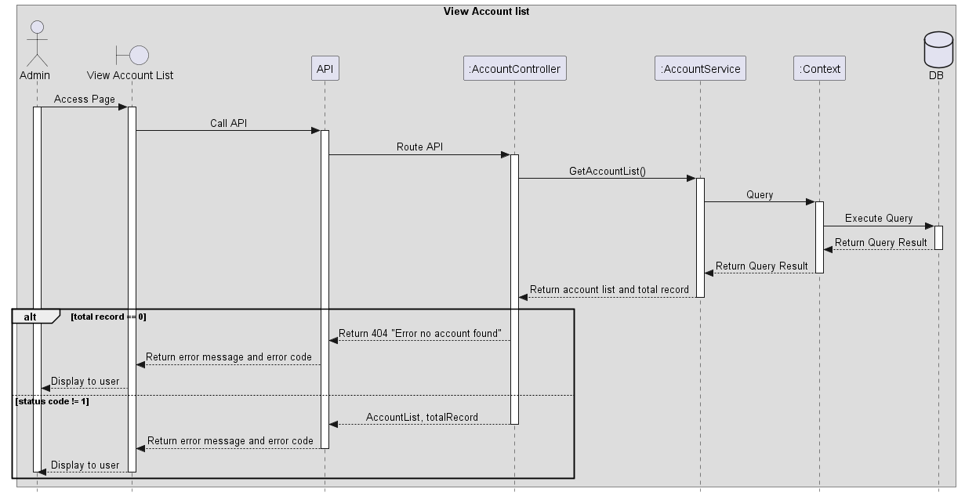
Figure 9 View Account List

Update Account
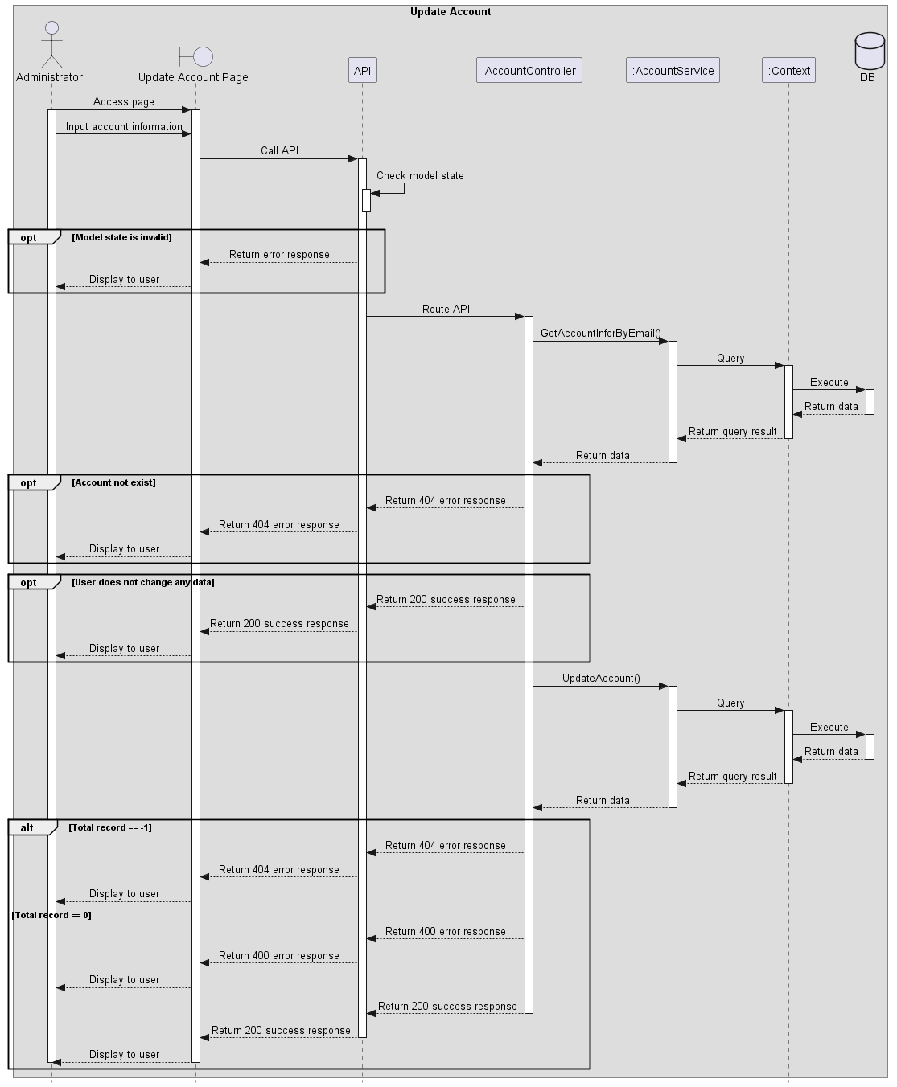
Figure 10 Update Account

Deactivate Account
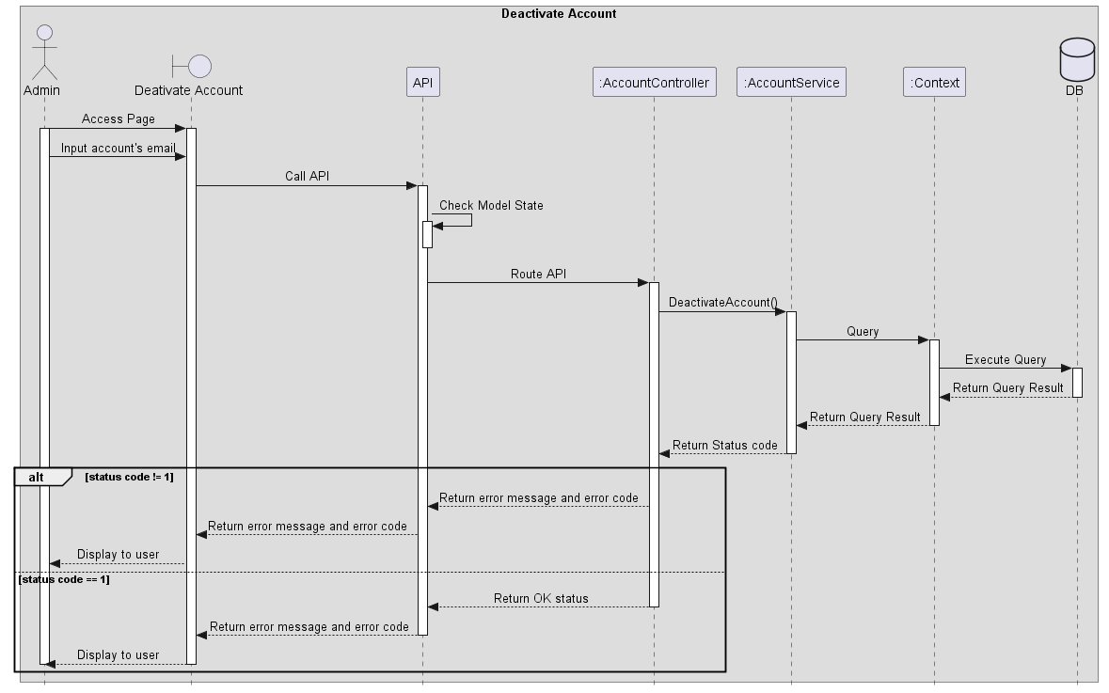
Figure 11 Deactivate Account

View deactivated account list
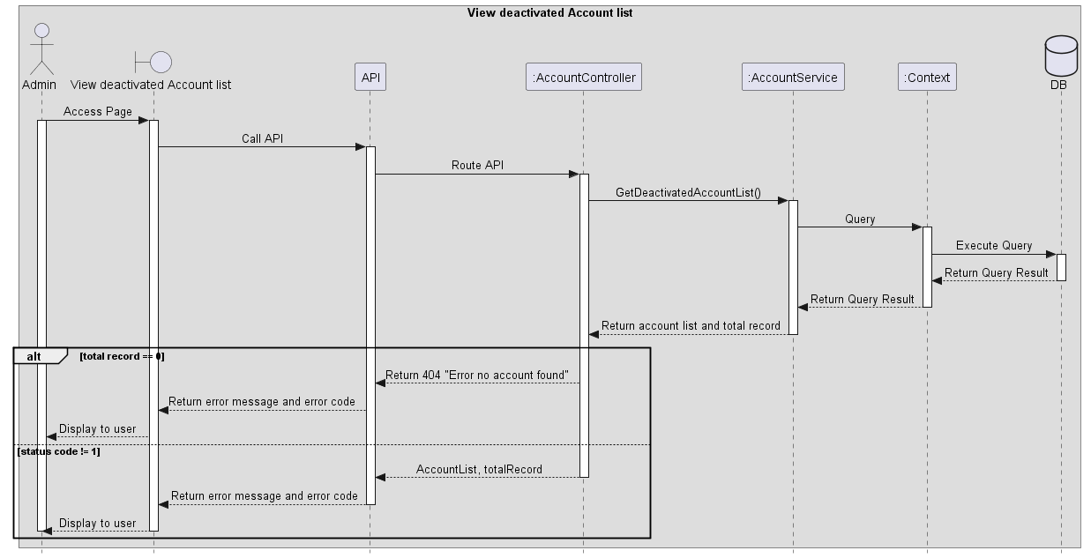
Figure 12 View deactivated account list

Create Module
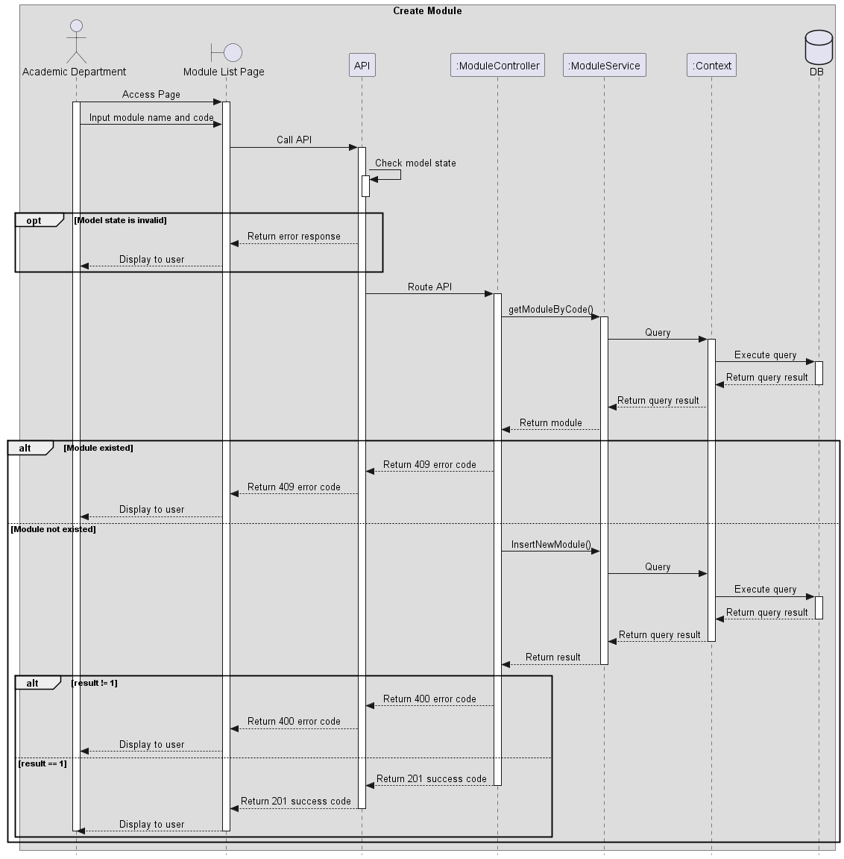
Figure 13 Create Module

View Module list
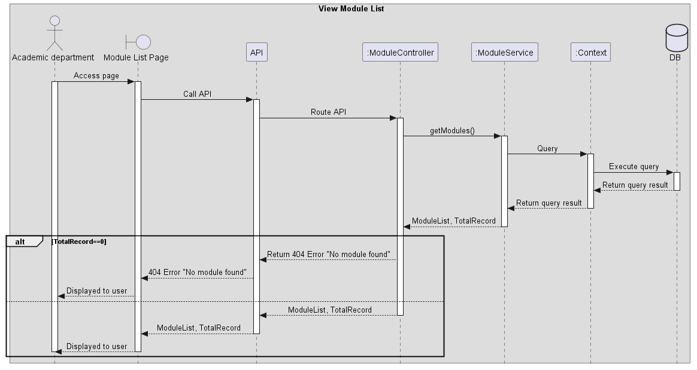
Figure 14 View Module list

Update Module
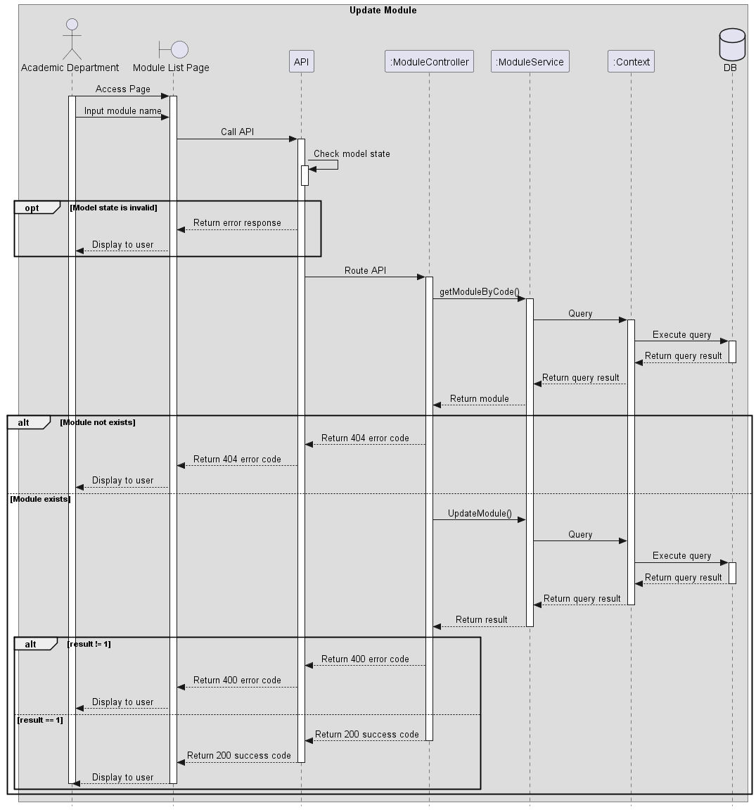
Figure 15 Update Module

Delete Module
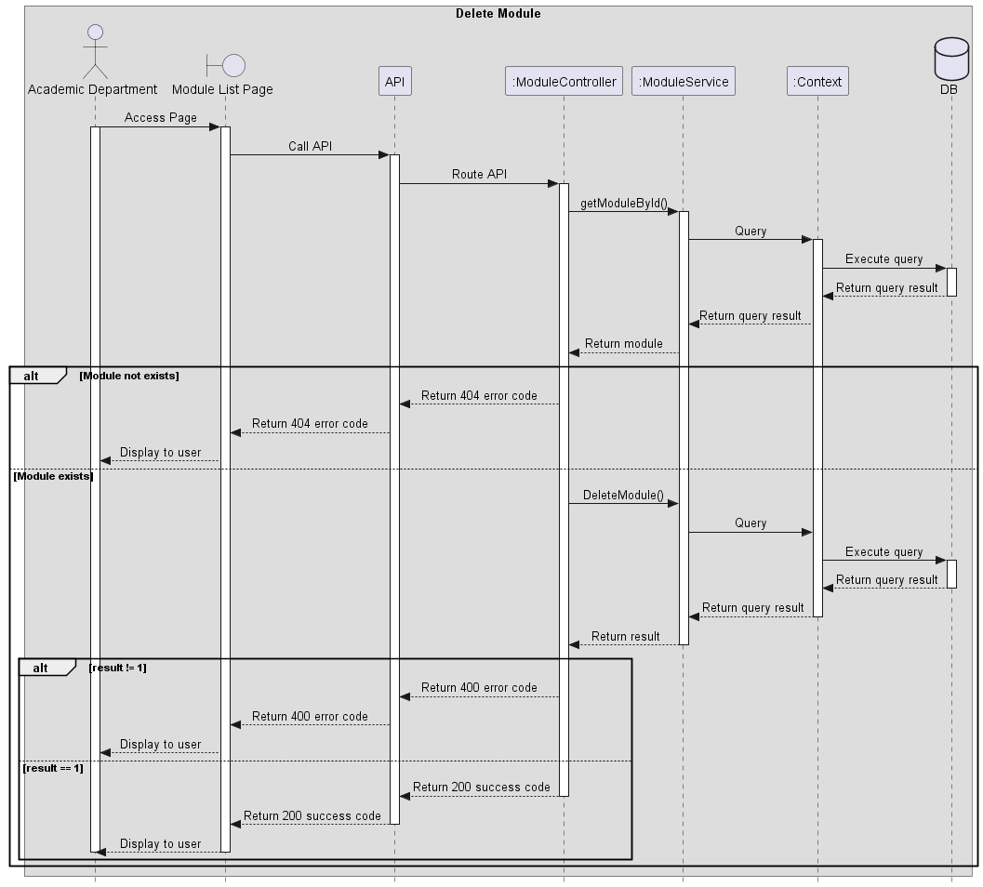
Figure 16 Delete Module

Create Class
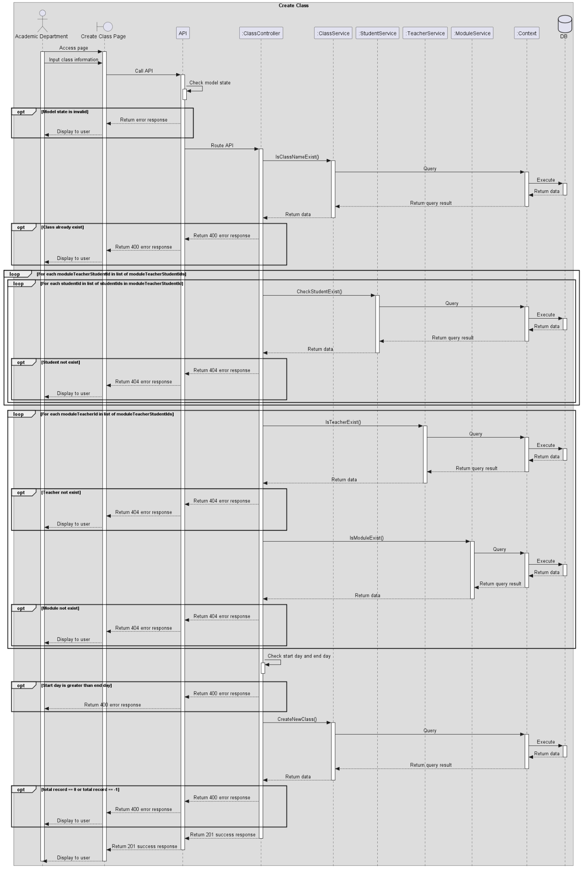
Figure 17 Create Class

View Class List (Academic Department Role)
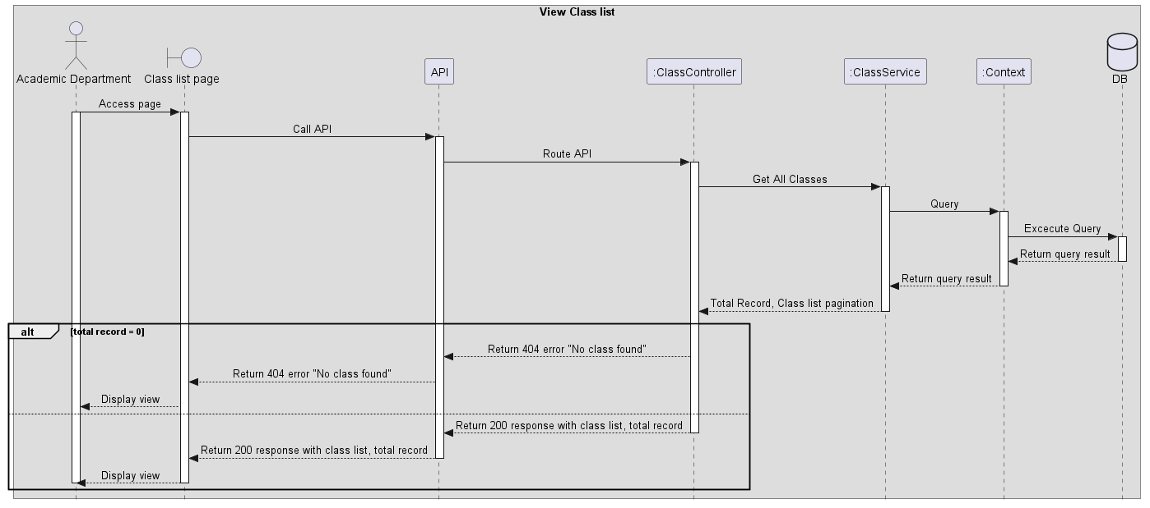
Figure 18 View Class List

Update Class (Academic Department Role)
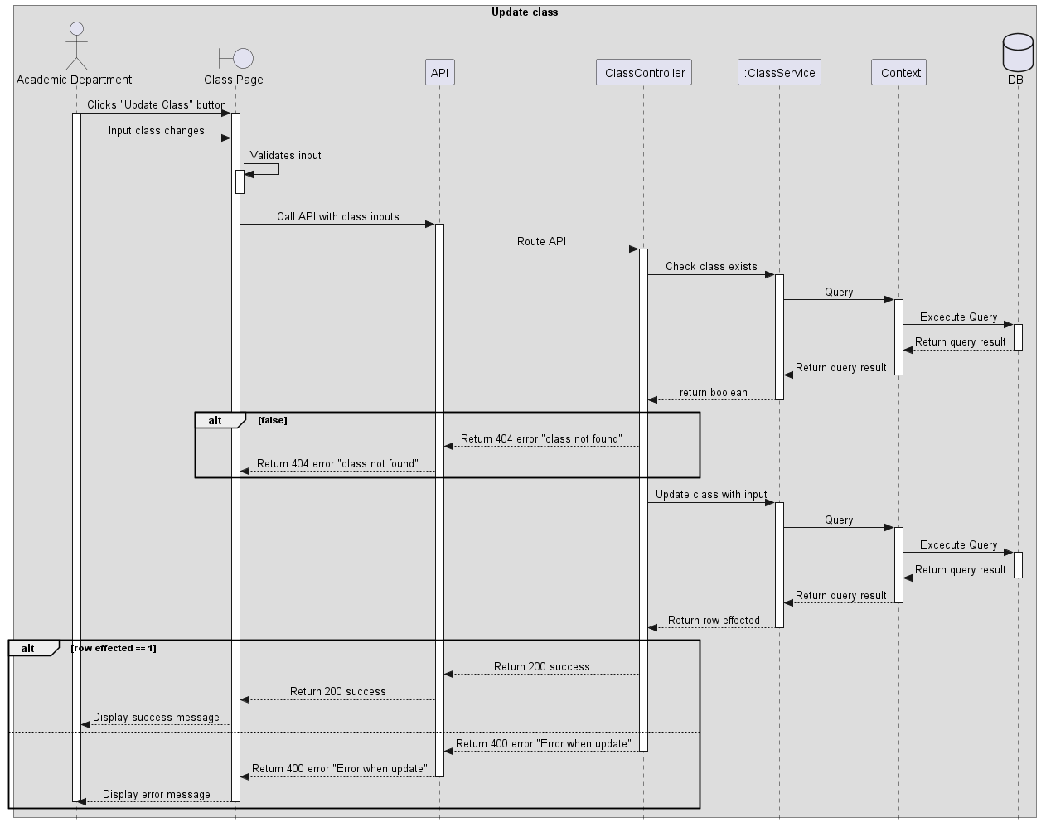
Figure 19 Update Class

Create Final Exam
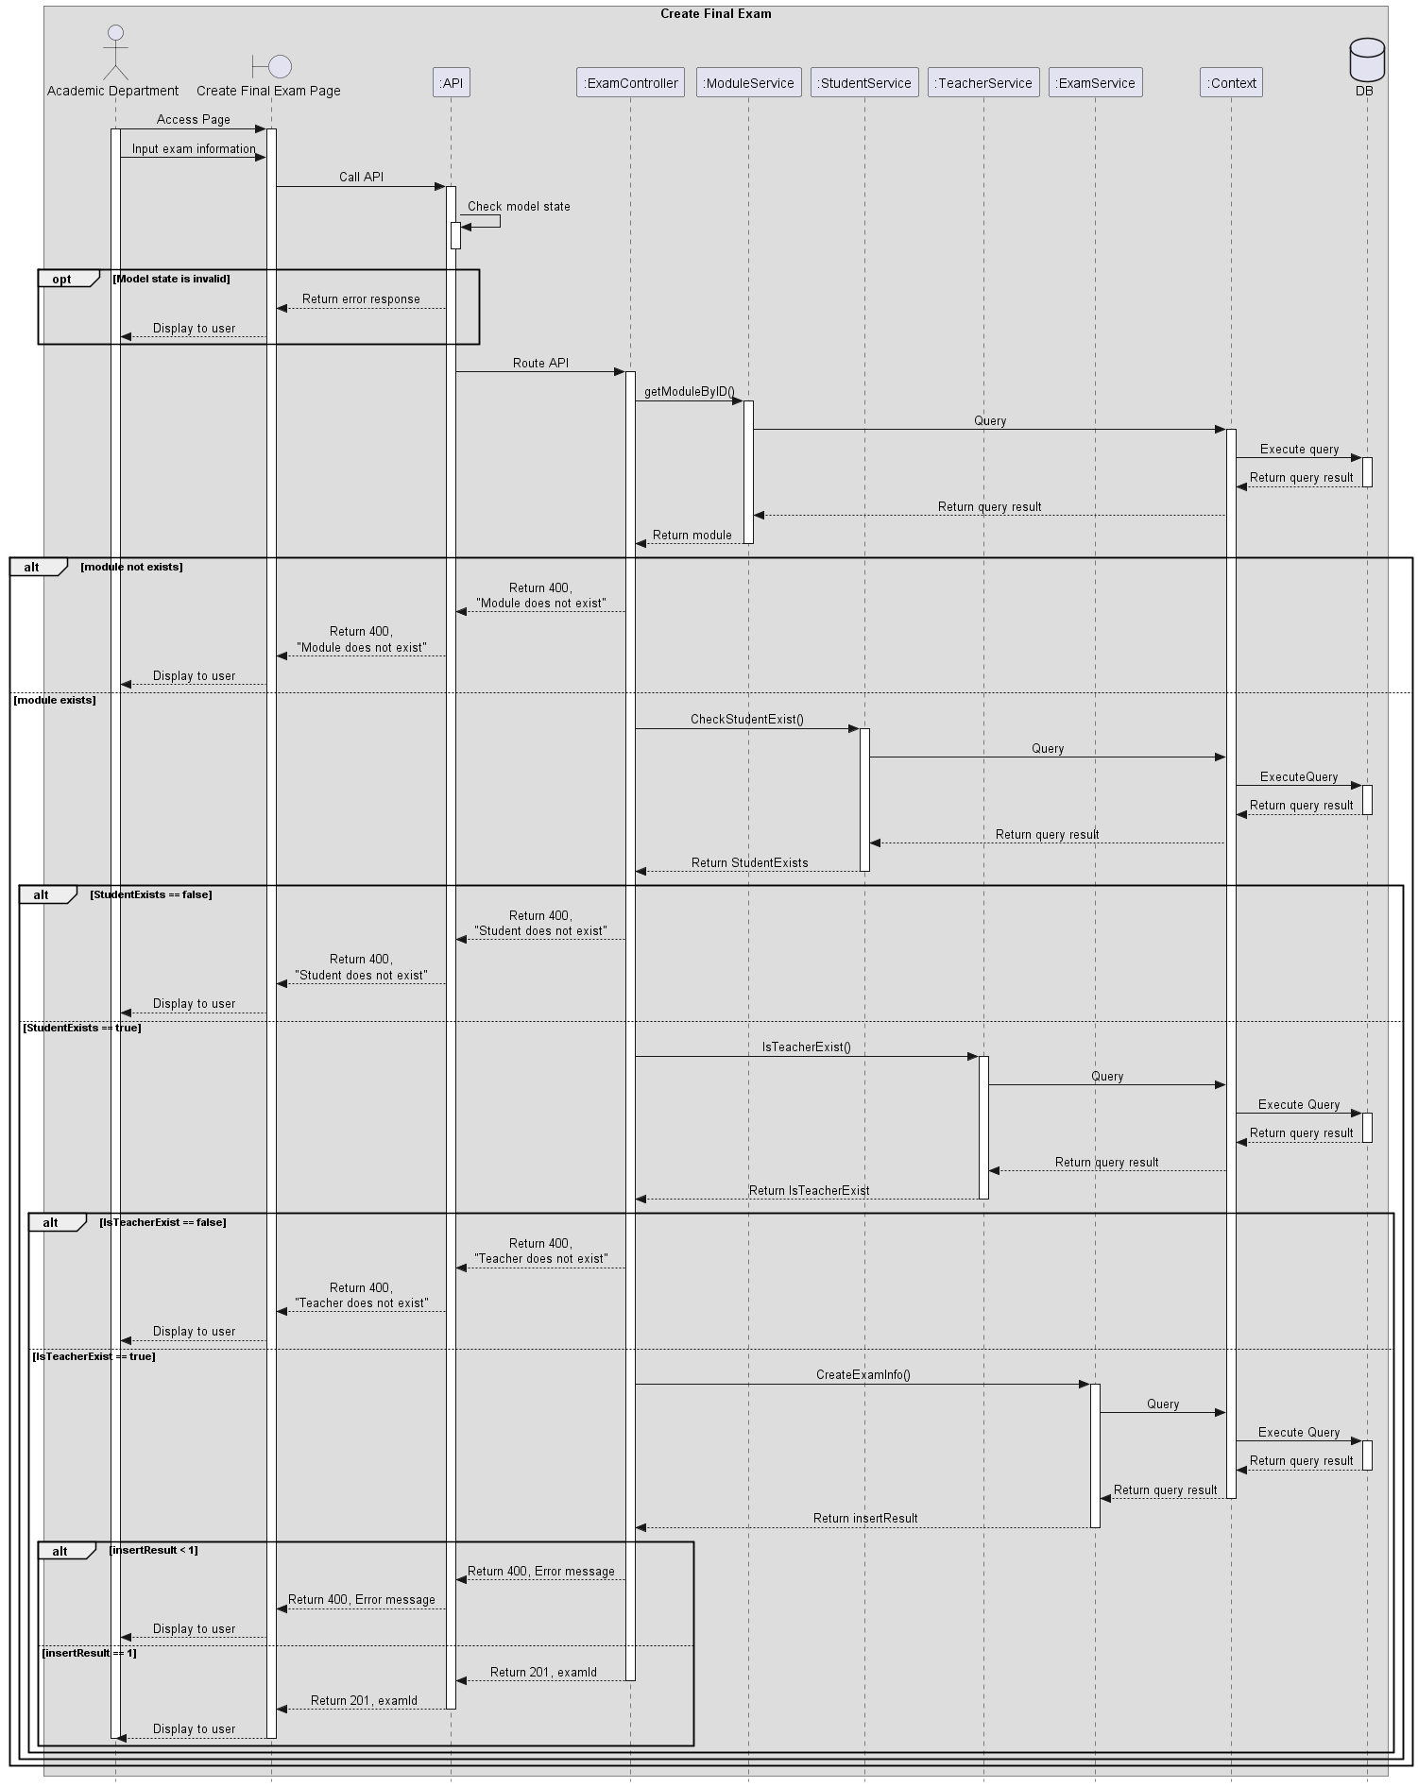
Figure 20 Create Final Exam

View Exam List
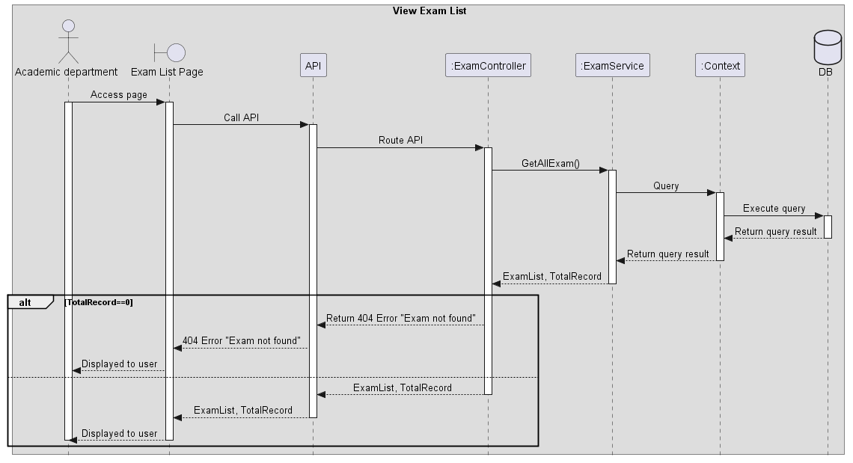
Figure 21 View Exam List

Update Final Exam
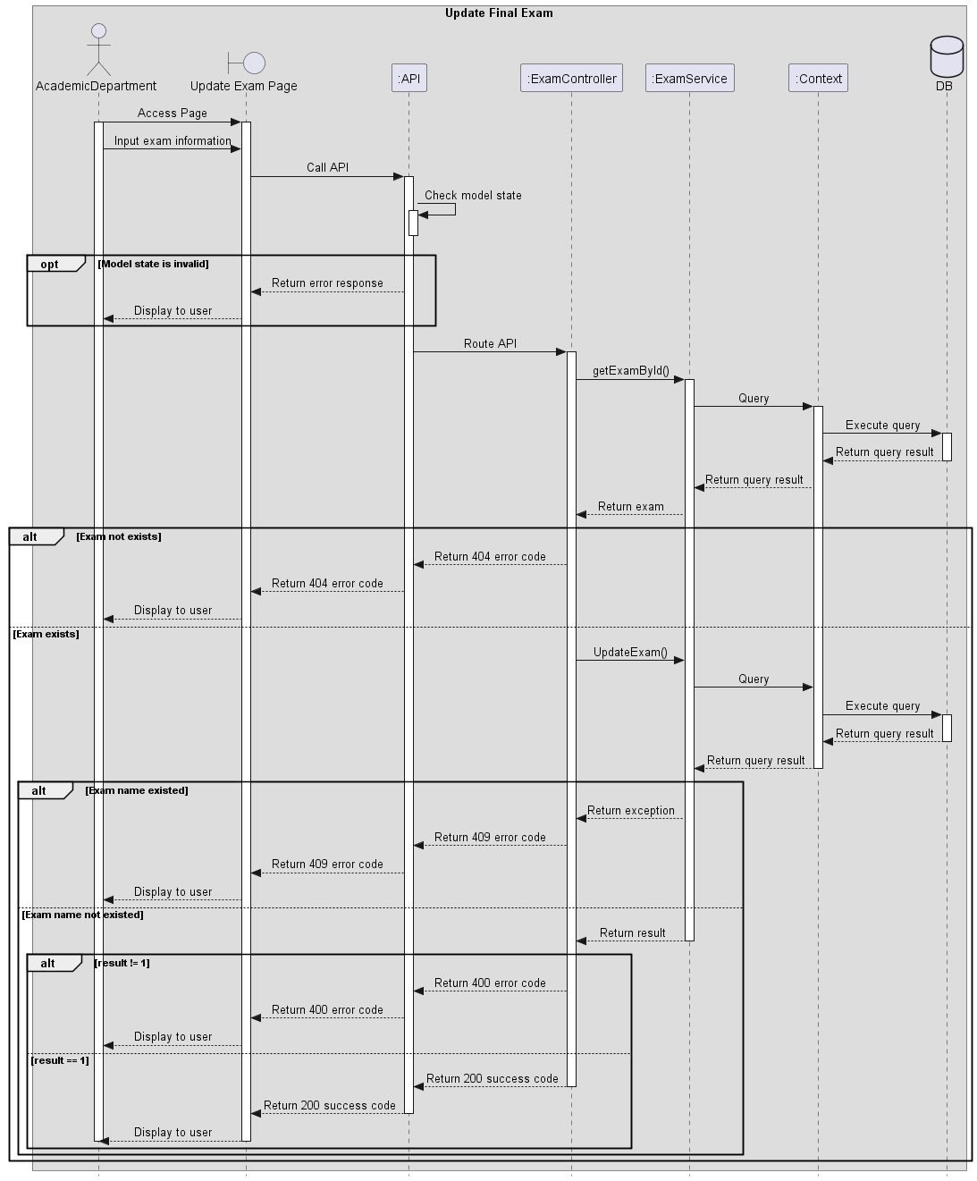
Figure 22 Update Final Exam

Delete Exam (Academic Department Role)
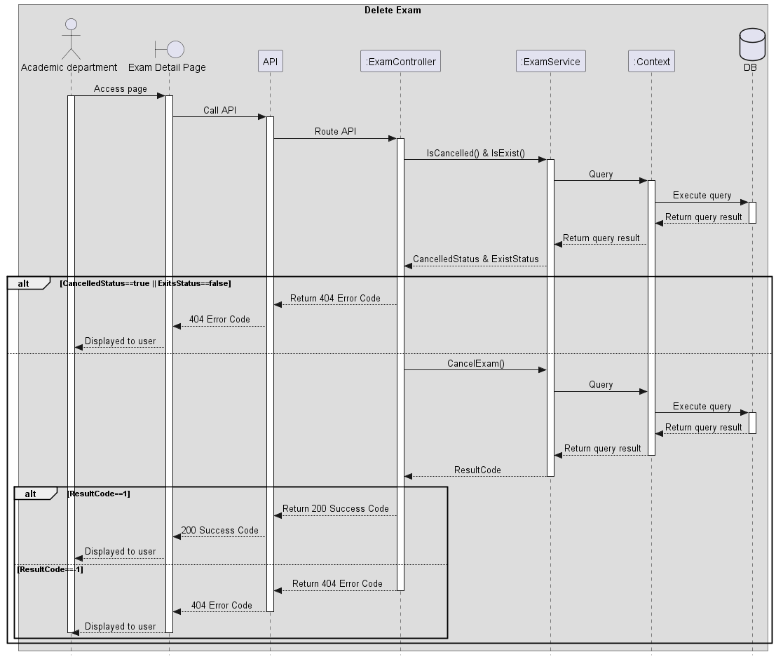
Figure 23 Delete Exam

View module list
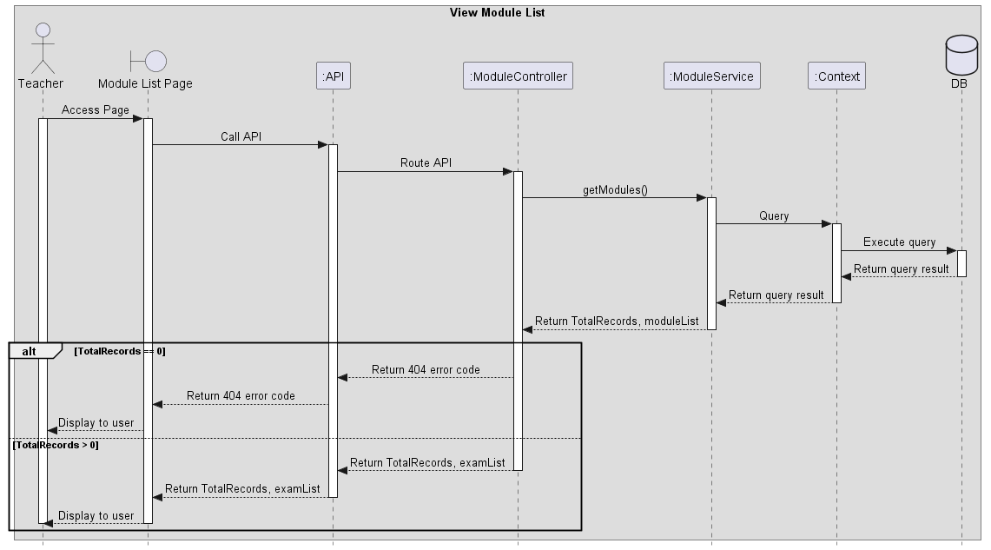
Figure 24 View module list

Create Exam

Figure 25 Create Exam

View Exam List
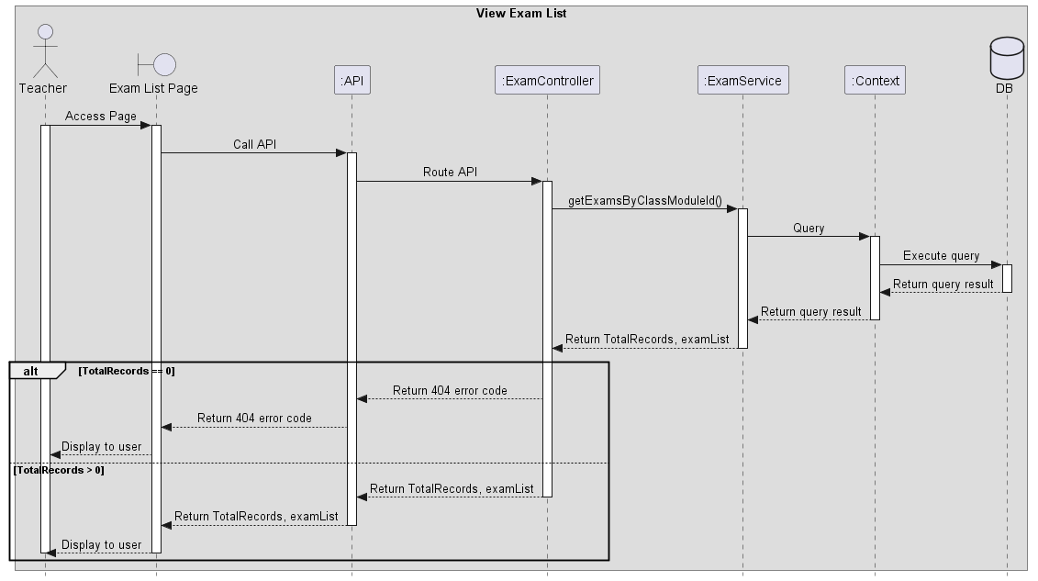
Figure 26 View Exam List

Update Exam
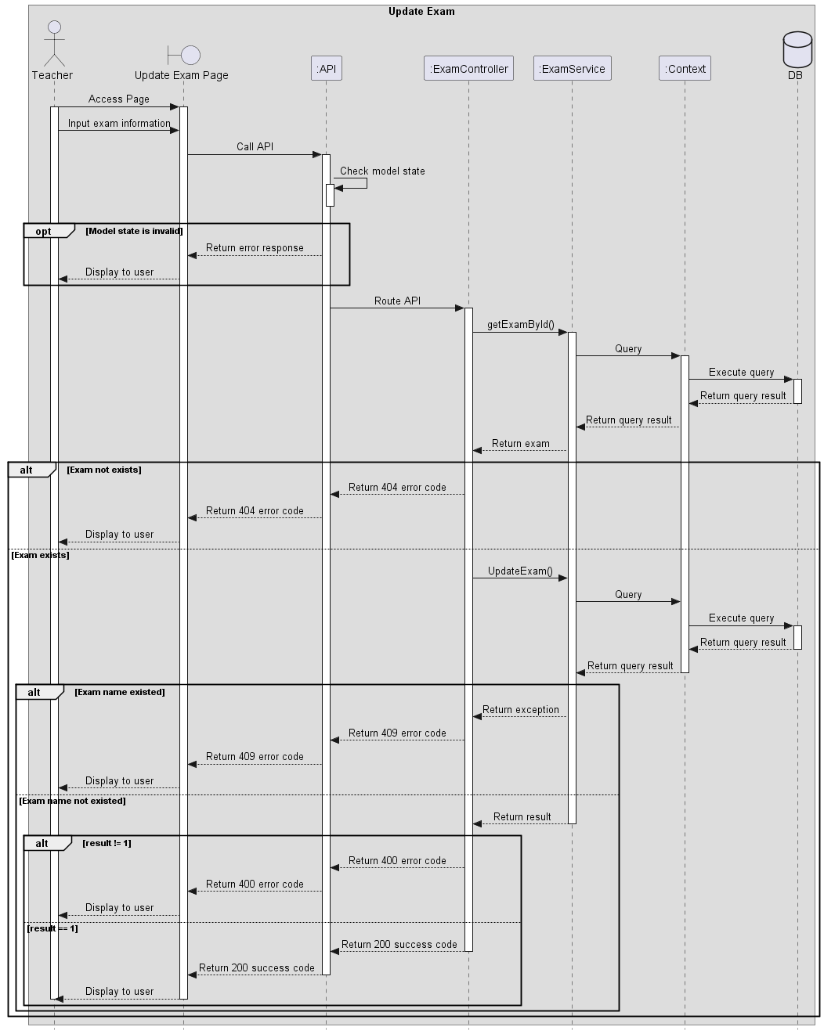
Figure 277 Update Exam

Delete Exam (Teacher Role)
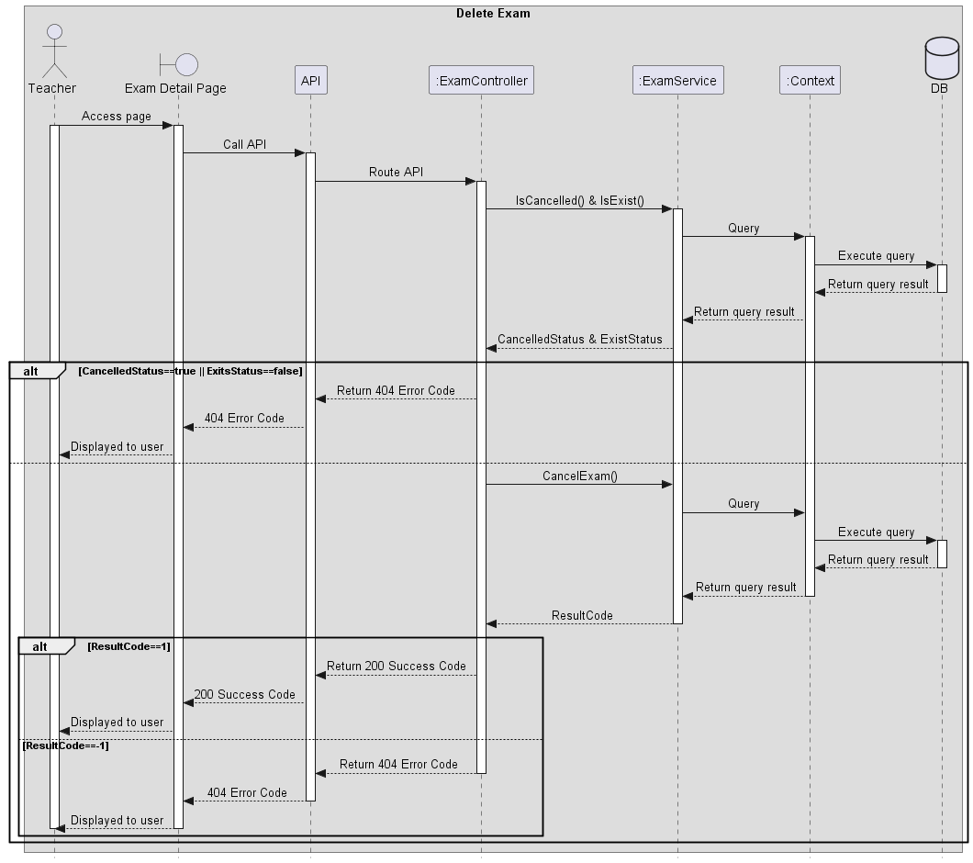
Figure 28 Delete Exam

Export excel module’s exam results (Teacher Role)
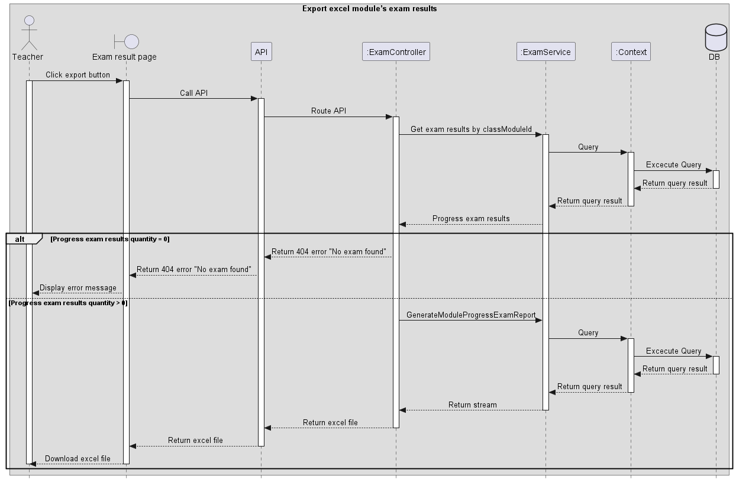
Figure 29 Export excel module’s exam results

View exam result, analysis
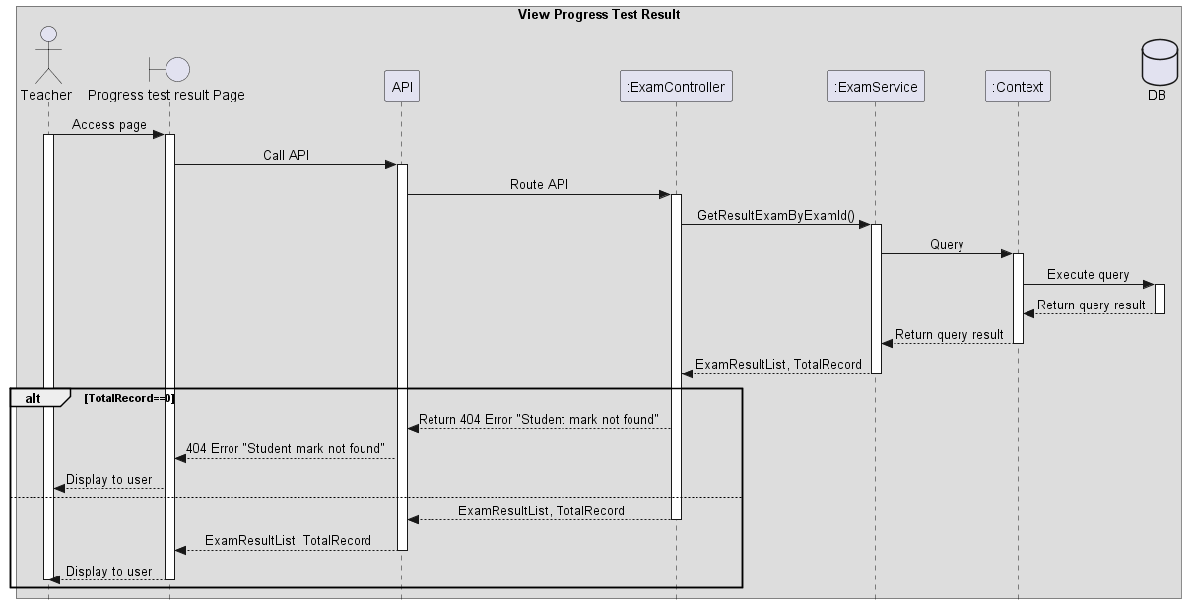
Figure 30 View exam result, analysis

Create exam paper
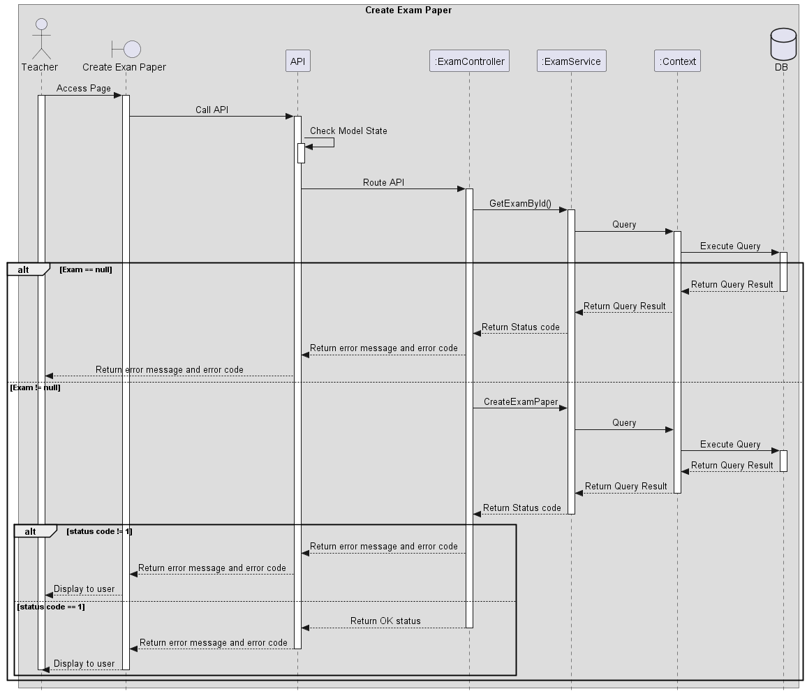
Figure 31 Create exam paper

Grade written questions (Teacher Role)
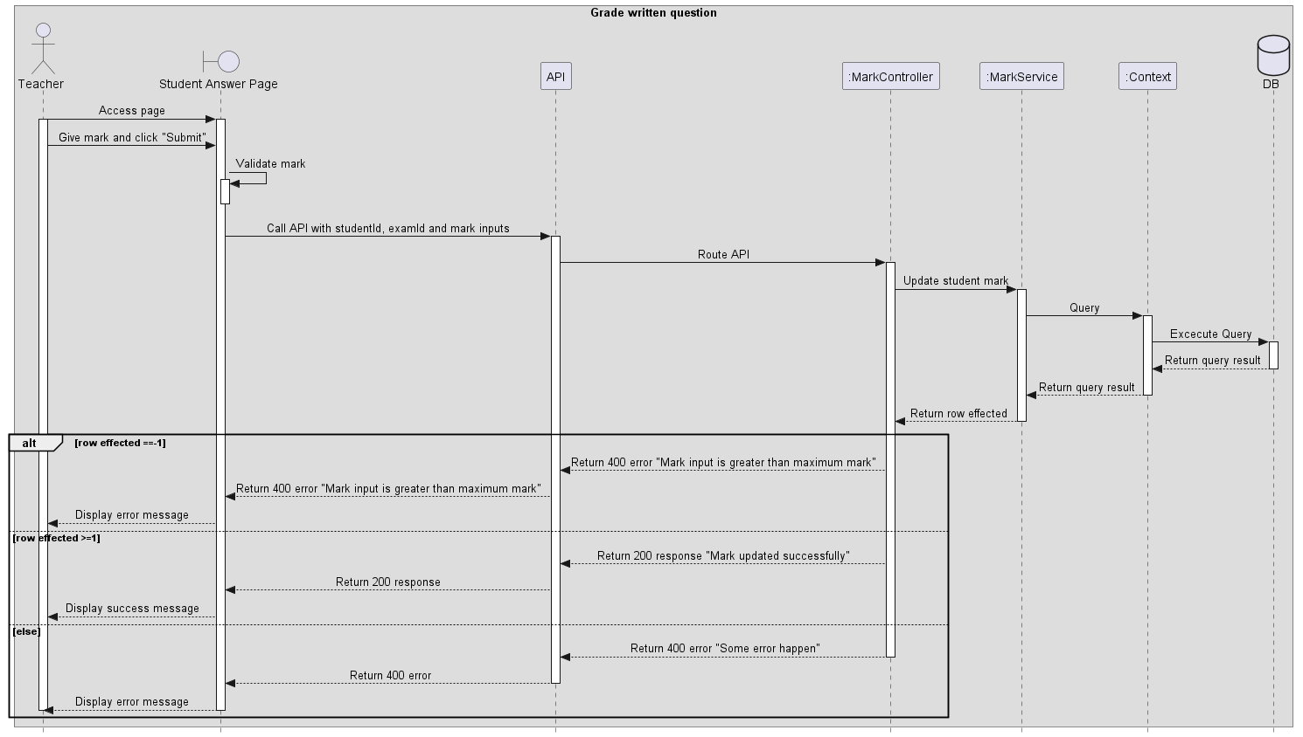
Figure 32 Grade written questions

View all requests add question bank
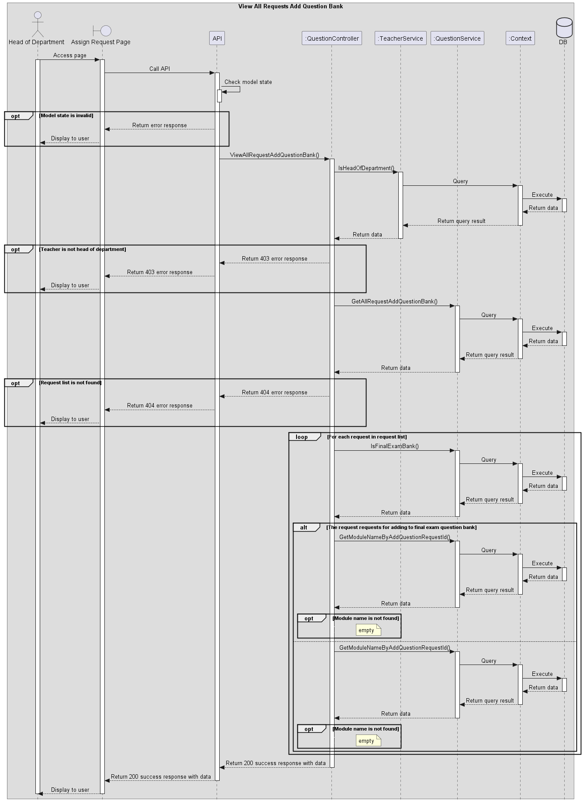
Figure 33 View all requests add question bank

Approve/Reject request to add question
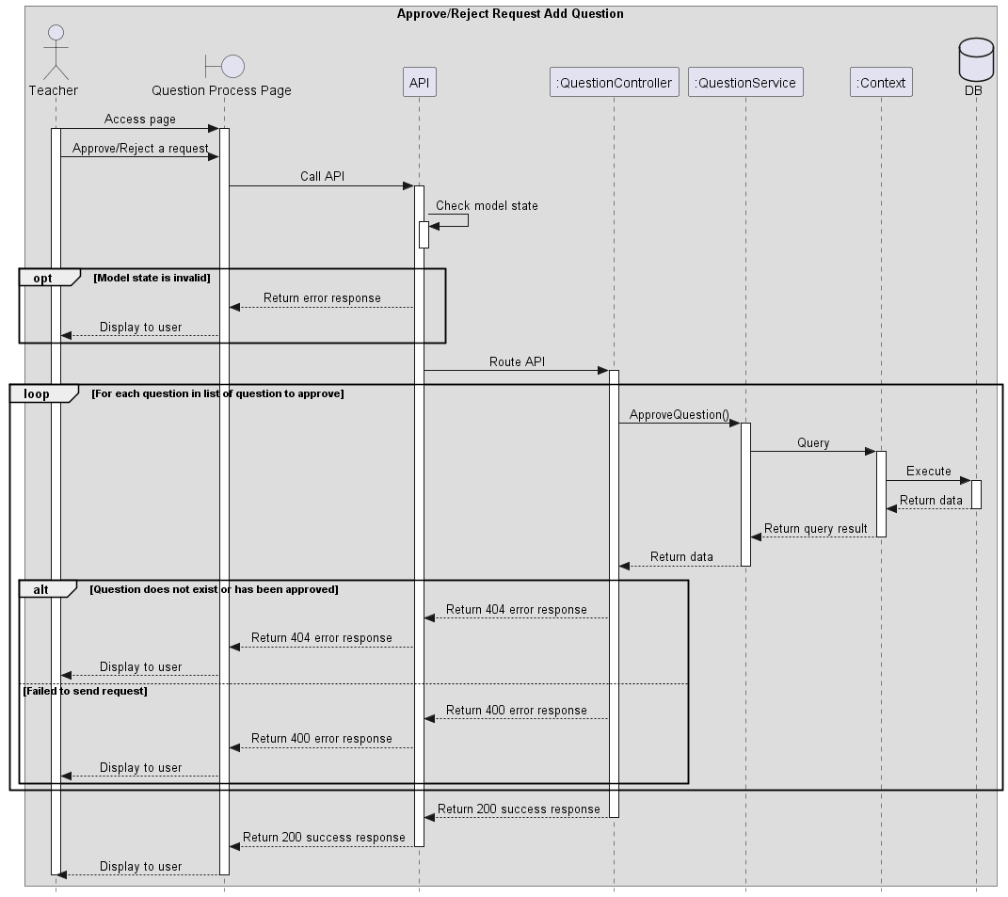
Figure 34 Approve/Reject request to add question

Request add new question to question bank
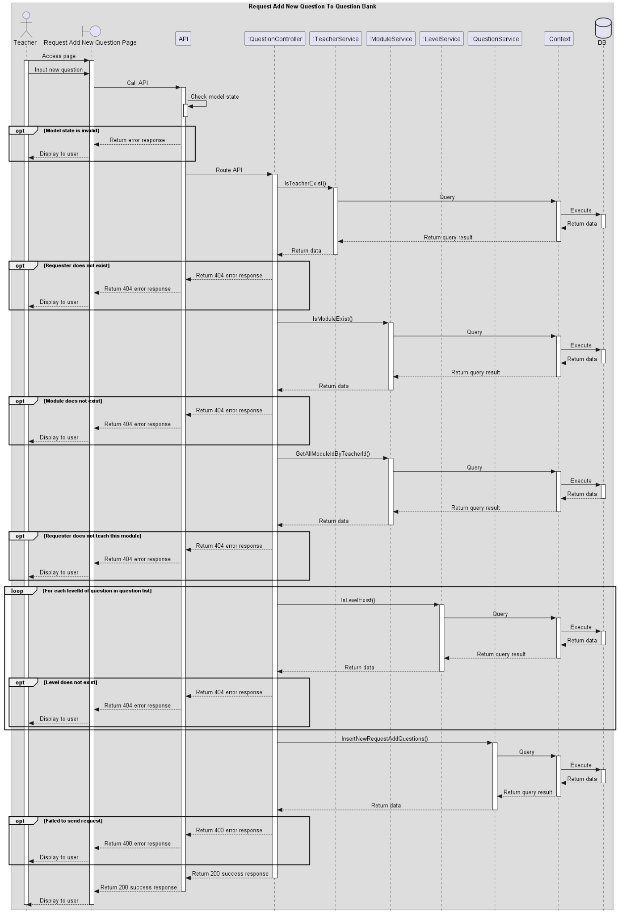
Figure 35 Request add new question to question bank

Assign teacher to process add question request
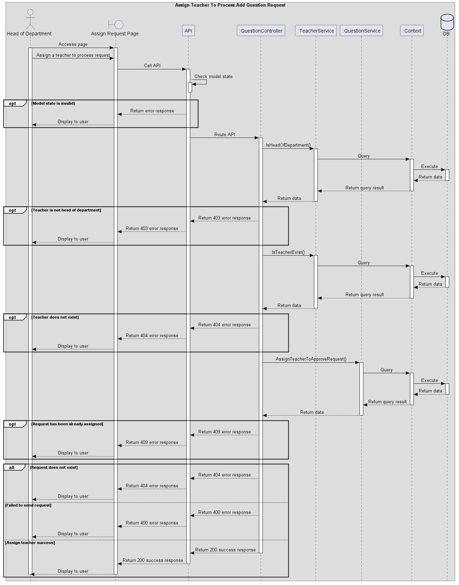
Figure 36 Assign teacher to process add question request

View exam schedule (Student Role)
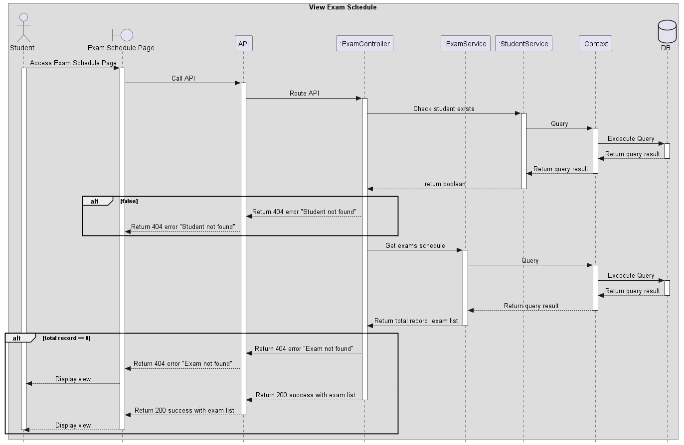
Figure 37 View exam schedule

View exam questions
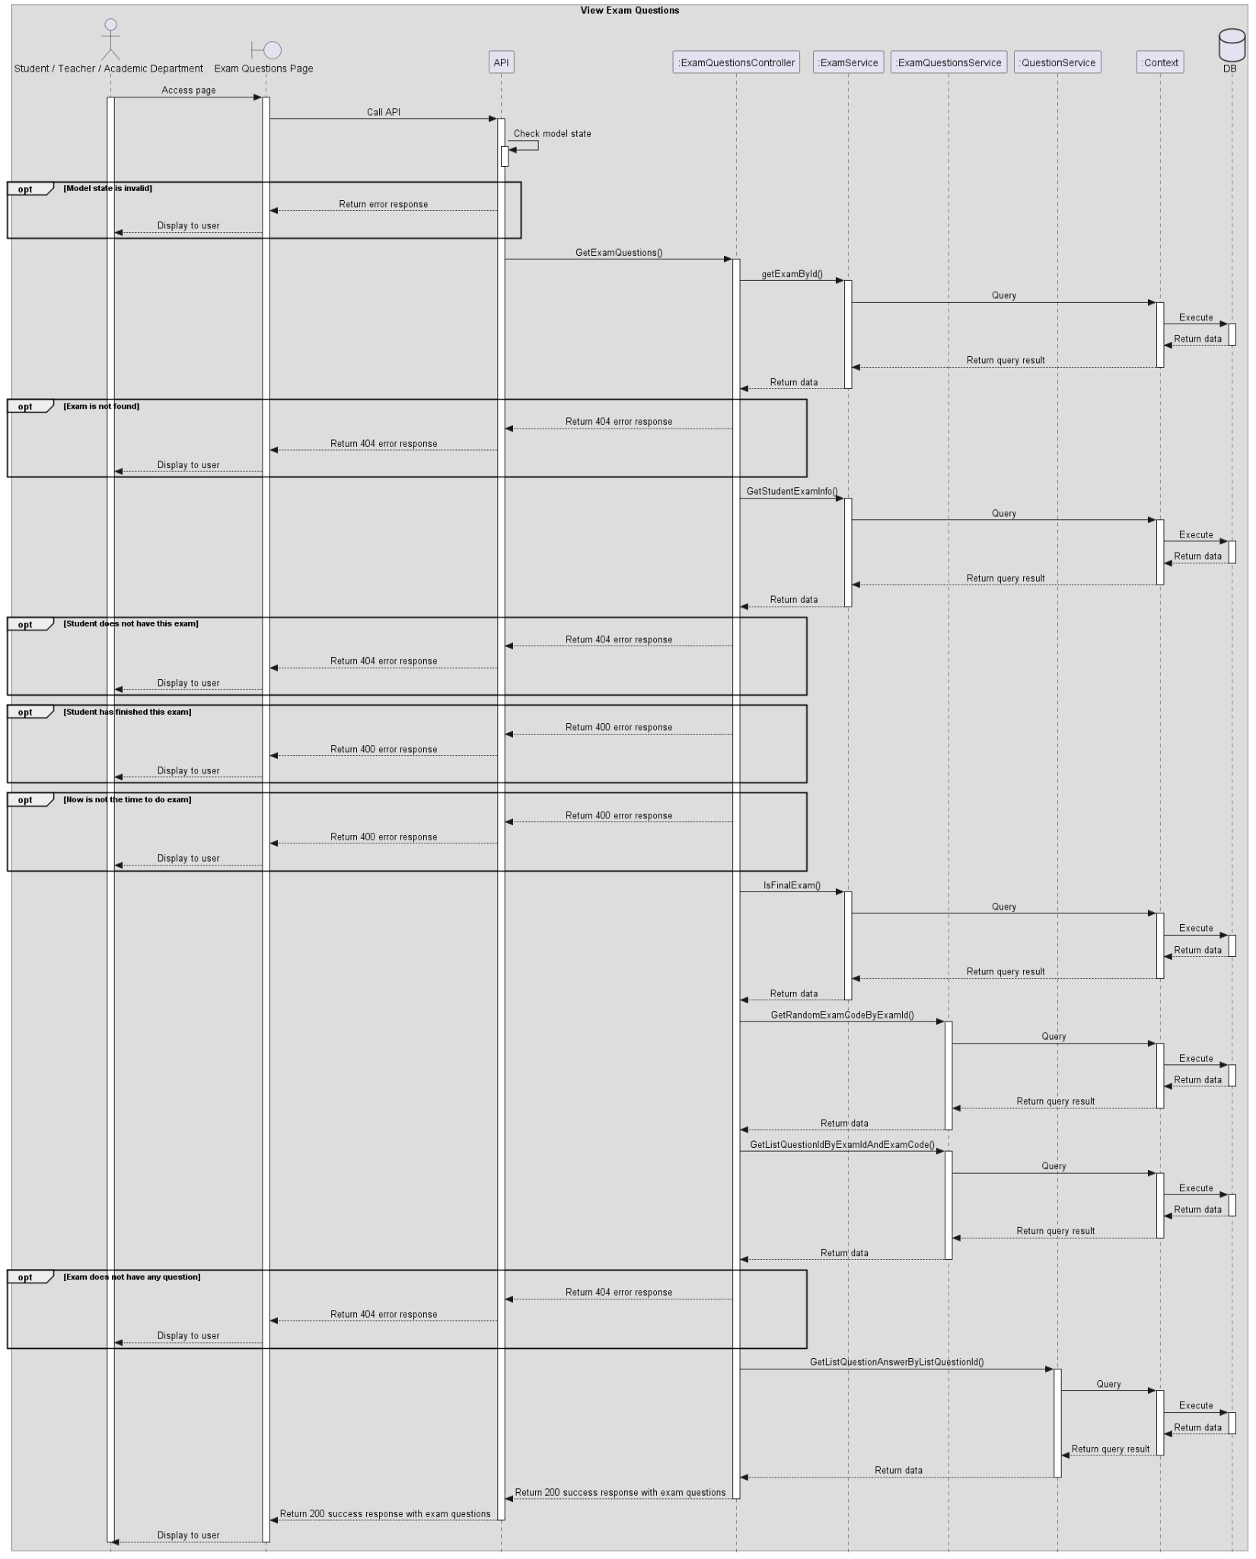
Figure 38 View exam questions

Submit exam (Student Role)
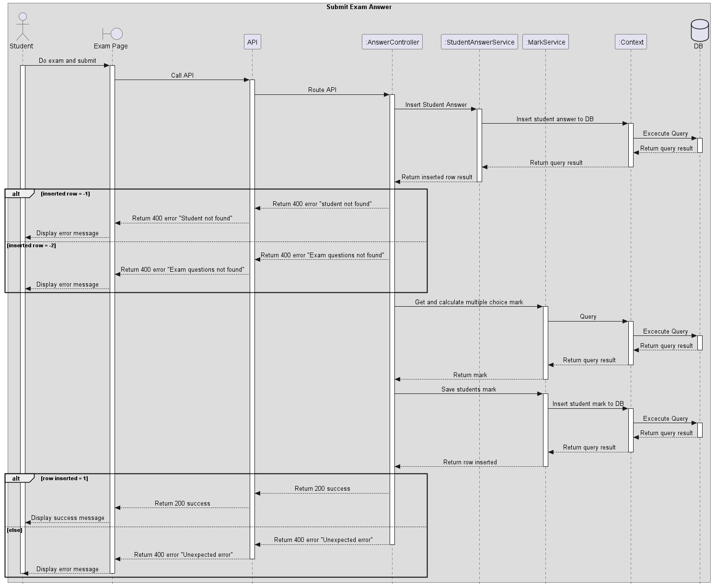
Figure 39 Submit exam

Mark report
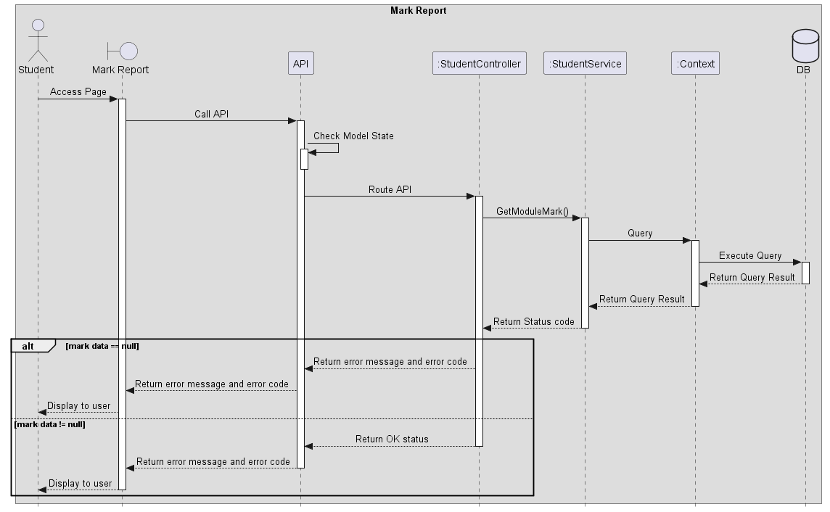
Figure 40 Mark report

View module list by Student
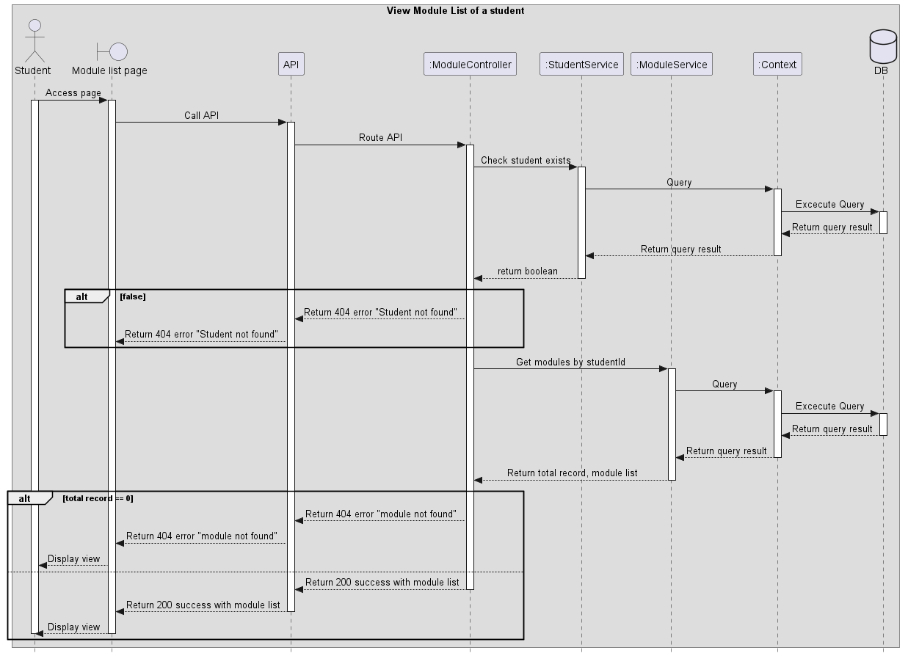
Figure 41 View module list

Invigilate
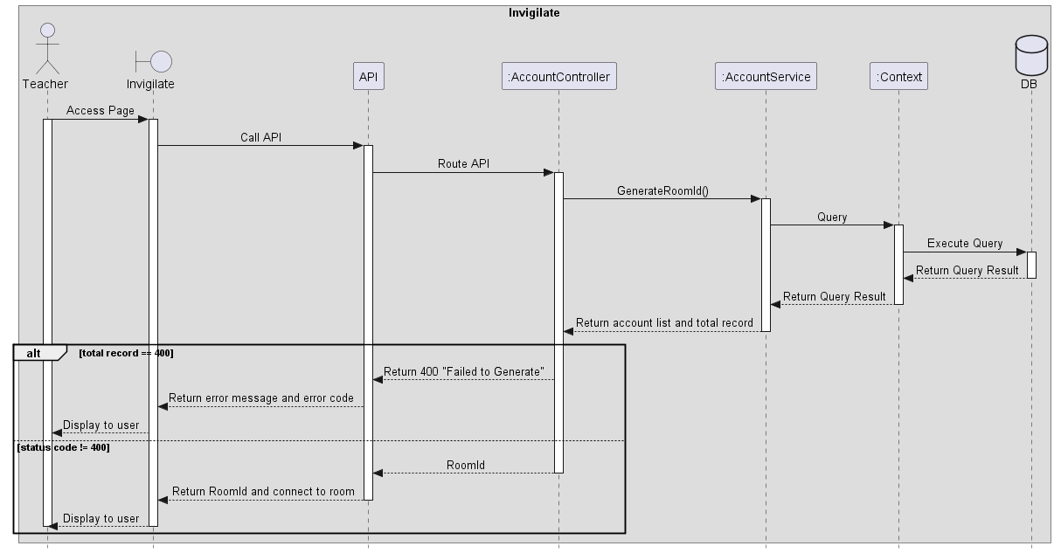
Figure 42 Invigilate

4. Class Specifications

4.1 AcademicDepartmentController Class

4.1.1 Class Methods
No | Method | Description
1 | GetAcademicDepartmentList | Get a list of Academic Department.

4.1.2 Attributes of the Class
No | Attribute | Type
1 | _mapper | IMapper
2 | _academicDepartmentService | IAcademicDepartmentService

4.2 AccountController Class

4.2.1 Class Methods
No | Method | Description
1 | AccountController | Class constructor, used to instantiate the controller and bind necessary attributes through dependency injection.
2 | GetAccountList | A method for administrator to get a list of all activated accounts with pagination support.  function GetAccountList(Argument paginationParameter){  retrieve a list of all activated accounts and total record with paginationParameter  if there is no total record then return “Search email not found” error message  return a success message with a list of all activated accounts and total record in the pagination format  }
3 | GetDeactivatedAccountList | A method for administrator to get a list of all deactivated accounts with pagination support.  function GetDeactivatedAccountList(Argument paginationParameter){  retrieve a list of all deactivated accounts and total record with paginationParameter  if there is no total record then return “Search email not found” error message  return a success message with a list of all deactivated accounts and total record in the pagination format  }
4 | CreateNewAccount | A method for administrator to create a new account and send an email contains password to user’s email address.  function CreateNewAccount(Argument accountInput){  insert a new account to database and send an email contains password to user’s email address  if insert fail then return “Email is already existed” error message  if unexpected error occur then return “Something went wrong. Please try again” error message  return a success message  }
5 | CreateNewAccountByExcel | A method for administrator to create multiple accounts simultaneously from an excel file and send an email contains password to each user’s email address.  function CreateNewAccountByExcel(Argument excelFile, Argument roleId){  convert excel file to a list of account information  if the excel file contains any error cell then return an error message with a list of error cell information  loop through each item of the account information list and assign roleId to each account  insert the list of account to database and send send an email contains password to each user’s email address  if any cell contain an existed email then return an error message with a list of error cell information  if inserting all accounts success then return “Successfully inserted” success message  return “Error when inserted, upload again for more detail” error message  }
6 | DeactivateAccount | A method for administrator to deactivate an account.  function DeactivateAccount(Argument id, Argument role){  deactivate account in the database by it’s id and role  if the account’s id is not existed in the database then return “Id not found!” error message  if unexpected error occur then “Deactivate failed” error message  return “Account has been deactived successfully!” success message  }
7 | GetAccountInforByEmail | A method for administrator to get all informations of an account by it’s email.  function GetAccountInforByEmail(Argument email){  retrieve all account’s information from database by it’s email  if account is not existed in the database then return “Account not exist” error message  return success message with all the account’s information  }
8 | UpdateAccount | A method for administrator to update an account’s information.  function UpdateAccount(Argument roleId, Argument currentEmail, Argument accountInput){  retrieve account information from database by currentEmail  if account does not exist then return “Account not exist” error message  if administrator does not change any account information then return “Update account success” success message  update account information in the database  if account does not exist then return “Account not exist” error message  else if updating fail then return “Something went wrong. Update account failed” error message  else return “Update account success” success message

4.2.2 Attributes of the Class
No | Attribute | Type
1 | _accountService | IAccountService
2 | _mapper | IMapper
3 | _studentService | IStudentService
4 | _teacherService | ITeacherService
5 | _academicDepartmentService | IAcademicDepartmentService
6 | _administratorService | IAdministratorService

4.3 AnswerController Class

4.3.1 Class Methods
No | Method | Description
1 | AnswerController | Class constructor, used to instantiate the controller and bind necessary attributes through dependency injection.
2 | SubmitAnswer | A method for students to submit their answers in an exam  function SubmitAnswer(Argument answerInputs, Argument examId, Argument studentId){  insert student’s answers into the database  if fails then return appropriate error message  else {  grade the student’s answer  insert the student’s grade into the database  if insert successfully then return a message with the grade included  else return error message  }  }
3 | SubmitFEAnswer | A method for students to submit their answers in a final exam  function SubmitFEAnswer(Argument answerInputs, Argument examId, Argument studentId){  insert student’s answers into the database  if fails then return appropriate error message  else {  grade the student’s answer  insert the student’s grade into the database  if insert successfully then return a message with the grade included  else return error message  }  }
4 | ViewStudentTextAnswer | A method to retrieve a student’s written answer in an exam  function ViewStudentTextAnswer(Argument studentId, Argument examId){  retrieve student’s written answers from the appropriate question bank  if student does not have written answers then return “Student don’t have text answer” error message  else return the written answers  }

4.3.2 Attributes of the class
No | Attribute | Type
1 | _studentAnswerService | IStudentAnswerService
2 | _mapper | IMapper
3 | _markService | IMarkService
4 | _examService | IExamService

4.4 AuthenticationController Class

4.4.1 Class Methods
No | Method | Description
1 | AuthenticationController | Class constructor, used to instantiate the controller and bind necessary attributes through dependency injection.
2 | Login | A method for user to log in to ExamEdu in order to use all functions based on the user's role.  function Login(Argument loginInput){  retrieve account information from database by user’s email address  if cannot find the account in the database then return “Wrong credentials or account has been deactivated” error message  verify password of user  if result of verification is false then return “Wrong credentials” error message  retrieve role name from database  create claims including email and role for adding to payload in access token  generate access token and refresh token  if fail then return “Token generate fail” error message  add refresh token to cookies  add access token to the response data  return success message and user data  }
3 | Logout | A method for user to log out from ExamEdu.  function Logout(){  get refresh token from cookies  if fail then return “No cookies found!” error message  retrieve user’s email from the refresh token  remove the refresh token by user’s email  catch any exception and return “Fail to remove refresh token.” error message  return “Logout success!” success message  }
4 | ForgotPassword | A method for user to reset account password and receive a newly generated password by email.  function ForgotPassword(Argument email){  retrieve account information by email  if account information is null then return “Email does not exist or has been deactivated” error message  update password of user’s account to database and send an email contain new password to user’s email address  if success then return “An email contains new password has been sent to your email address. Please check your email to get the new password.” success message  else return “Reset password fail. Please try again.” error message  }

4.4.2 Attributes of the Class
No | Attribute | Type
1 | _mapper | IMapper
2 | _accountService | IAccountService
3 | _jwtGenerator | IJwtGenerator
4 | _refreshToken | IRefreshToken

4.5 CheatController Class

4.5.1 Class Methods
No | Method | Description
1 | CheatController | Class constructor, used to instantiate the controller and bind necessary attributes through dependency injection.
2 | CheatingTypeList | A method to retrieve all cheating types available in the system.  function CheatingTypeList()  {  retrieve all cheating types  if cheating type list is null or empty then return error message  else return a list of cheating types  }
3 | StudentCheating | function StudentCheating(Argument studentCheatingInput)  {  if studentId or examId not valid  then return error message  insert StudentCheating to database  if unexpected error happen then return error message  else return success message  }

4.5.2 Attributes of the Class
No | Attribute | Type
1 | _cheatService | ICheatService
2 | _studentService | IStudentService
3 | _mapper | IMapper
4 | _examService | IExamService

4.6 ClassController Class

4.6.1 Class Methods
No | Method | Description
1 | ClassController | Constructor of the class.
2 | GetClasses | This is a method used to return all the classes that belong to a module of a teacher.
3 | GetAllClasses | This is a method used to return all the class that the system have.
4 | GetAllStudentOfClass | This is a method used to return all students of a class.
5 | CreateNewClass | This is a method used to create a new class for the system.
6 | GetClass | This is a method used to return the basic information of a class.
7 | UpdateClassBasicInfor | This is a method used to update basic information of a class.

4.6.2 Attributes of the Class
No | Attribute | Type
1 | _classService | IClassService
2 | _classModuleService | IClassModuleService
3 | _mapper | _mapper
4 | _moduleService | _moduleService
5 | _teacherService | _teacherService
6 | _studentService | _studentService

4.7 ClassModuleController Class

4.7.1 Class Methods
No | Method | Description
1 | ModuleController | Class constructor, used to instantiate the controller and bind necessary attributes through dependency injection.
2 | ViewModuleStudentHaveLearn | A method to get all module student learned through student Id  function ViewModuleStudentHaveLearn(Argument studentId, Argument paginationParameter){  if studentId does not exist in database then return “student not exist” error message  retrieve class module information  if retrieved module list is null then return “No module found” message  else return module list in pagination  }
3 | ViewAllModule | A method to get all module  function ViewAllModule(Argument paginationParameter){  retrieve all module by paginationParameter  if module list is null then return “No module found” message  else return module in pagination  }
4 | GetModules | A method to get a list of module through teacher Id  function GetModules(Argument teacherId, Argument paginationParameter){  if teacherId does not exist in database then return “teacher not exist” error message  retrieve module list by teacherId and paginationParameter  if module list is null then return “No module found” message  else return module list in pagination  }
5 | CreateModule | A method to create module  function CreateModule(Argument moduleInput){  if module input code exist in database then return “module already exists” error message  insert module to database  if unexpected error happen then return “Something went wrong” message  else return success message  }
6 | UpdateModule | A method to update module  function updateModule(Argument moduleInput){  if module input code does not exist in database then return “module not found” error message  update module from database  if unexpected error happen then return “Something went wrong” message  else return success message  }
 | DeleteModule | A method to delete module  function CreateModule(Argument moduleId){  if module id does not exist in database then return “module not found” error message  delete module from database  if unexpected error happen then return “Something went wrong” message  else return success message  }

4.7.2 Attributes of the class
No | Attribute | Type
1 | _studentService | IStudentService
2 | _mapper | IMapper
3 | _teacherService | ITeacherService
4 | _moduleService | IModuleService

4.8 ExamController Class

4.8.1 Class Methods
No | Method | Description
1 | ExamController | Class constructor, used to instantiate the controller and bind necessary attributes through dependency injection.
2 | GetExamScheduleByStudenId | A method to retrieve exam schedules of a student by their id  function GetExamScheduleByStudentId(Argument studentId, Argument paginationParameter){  if studentId does not exist in database then return “student not found” error message  retrieve student’s exam schedule  if student does not have any exams scheduled then return “student does not have exam scheduled” message  else return paginated exam schedule based on paginationParameter  }
3 | CreateExamByHand | A method to manually choose sets of questions for an exam  function CreateExamByHand(Argument input){  if exam does not exist then return “Exam not existed” error message  insert question sets into the exam  if insert succeed then return message “Successfully inserted”  else return error messages  }
4 | CreateExamAuto | A method to automatically generate sets of questions for an exam  function CreateExamAuto(Argument input){  if exam does not exist then return “Exam not existed” error message  generate and insert sets of questions for the exam based on input  if success then return message “Successfully inserted”  else return error messages  }
5 | GetExamById | A method to retrieve information about an exam  function GetExamById(Argument id){  retrieve the exam using the provided id  if exam does not exist then return “Exam not found” error  else return the exam’s information  }
6 | GetProgressExam | A method to retrieve information about a set of non-final exams for a class  function GetProgressExam(Argument classModuleId, Argument moduleId, Argument pagination parameter){  retrieve information about the set of non-final exams using the provided classModuleId and moduleId  if there are no exams then return “Exam not found” error  else return the paginated set of non-final exams  }
7 | CreateExamInfo | A method to create an exam’s information such as date, time, duration, students involved,...  function CreateExamInfo(input)  {  validate existence of related information in the input  if validation fails then return an appropriate “Not found” error message  else create the exam  if fail then return error message  else return success message and the exam’s id  }
8 | GetResultExam | A method to retrieve the result of an exam  function GetResultExam(Argument examId, Argument paginationParameter){  retrieve the result of an exam using examId  if there are no result then return “Student mark not found” error message  else return the paginated result  }
9 | ExportExamMarkReport | A method to export the marks of an exam into .xslx format  function ExportExamMarkReport(Argument examId, Argument classModuleId){  retrieve a list of mark based on examId  if the list is empty then return error message  else generate the report using the retrieved list and classModuleId and return the report  }
10 | UpdateExam | A method to update the information of an exam  function UpdateExam(Argument input){  if exam does not exist then return error message  else update the exam’s information  if success then return “Exam successfully updated” message  else return error message  }
11 | GetAllExam | A method to retrieve a list of all existing exams  function GetAllExam(Argument paginationParameter){  retrieve all existing exams  if list is empty then return “Exam not found” error message  else return the paginated list of exams  }
12 | GetExamInfoToUpdate | A method to retrieve information about an exam for updating purpose  function GetExamInfoToUpdate(Argument examId){  retrieve the exam’s information using examId  if exam does not exist then return “Exam not found” error message  else return the exam’s information  }
13 | CancelExam | A method to cancel a scheduled exam  function CancelExam(Argument examId){  if exam does not exist or is canceled then return error message  else cancel the exam  if success then return affirmation message  else return error messages  }
14 | ExportModuleProgressTest | A method to export all exam results of a class into .xlsx format  function ExportModuleProgressTest(Argument classModuleId, Argument moduleId){  retrieve a list containing all exam results of a class  if list is empty then return error message  else generate a report using the list and moduleId and return said report  }
15 | GetExamDetailById | A method to retrieve detail information about an exam  function GetExamDetailById(Argument exmId){  retrieve detail information about an exam using examId  if exam does not exist then return “Exam not found” error  else return the information  }
16 | GetExamByProctorId | A method to retrieve a list of exams of a proctor  function GetExamByProctorId(Argument proctorId, Argument paginationParameter){  retrieve a list of exams of a proctor  if list is empty then return “Not found” error message  else return the list of exams  }

4.8.2 Attributes of the class
No | Attribute | Type
1 | _mapper | IMapper
2 | _studentService | IStudentService
3 | _teacherService | ITeacherService
4 | _examService | IExamService
5 | _moduleService | IModuleService

4.9 ExamQuestionsController Class

4.9.1 Class Methods
No | Method | Description
1 | GetExamQuestions | Get the exam questions of an exam.  function GetExamQuestions(Argument examId, Argument studentId)  {  retrieve exam based on exam Id  if the exam does not exist return “Exam cannot be found!” error message  retrieve GetStudentExamInfo  if StudentExamInfo not exist return “Students do not have this exam” error message  if studentExamInfo.FinishAt != null return “You have done this exam before” error message  if ExamDay > now return “It is not time to do the exam” error message  retrieve question list  return question list  }
2 | GetExamQuestionsForExamDetail | Get a list of the questions and answers for an exam.  function GetExamQuestionsForExamDetail(Argument examId)  {  if the exam does not exist return “Exam does not exist.” error message  retrieve questionId list  if questionId list not exist return “This exam does not have any question” error message  retrieve question and answer list  return question and answer list  }

4.9.2 Attributes of the Class
No | Attribute | Type
1 | _mapper | IMapper
2 | _examQuestionsService | IExamQuestionsService
3 | _studentService | IStudentService
4 | _teacherService | ITeacherService
5 | _examService | IExamService
6 | _questionService | IQuestionService

4.10 InvigilateController Class

4.10.1 Class Methods
No | Method | Description
1 | GenerateRoomId | Generate a unique ID for the invigilating room.  function GenerateRoomId(Argument examRoomInfor)  {  retrieve exam info  if retrieve fail then return “Exam does not exist” error message  if examRoomId exist then invoke “restartConnection” function at client and return “Exam has been generated room” error message  generate examId  update examId to database  return Ok  }
2 | GetRoomId | Get room ID based on exam ID.  function GetRoomId(Argument examId)  {  retrieve exam info  if retrieve fail then return “Exam does not exist” error message  return roomId  }
3 | StartRoom | Start the Invigilating room.  function StartRoom(Argument ExamId)  {  invoke method ForceJoinRoom at client with the same ExamId  }
4 | StudentDisconnectNotify | Make a student call window disappear when they disconnect.  function StudentDisconnectNotify( Argument examRoomInfor)  {  Invoke method StudentDisconnect at client  }

4.10.2 Attributes of the Class
No | Attribute | Type
1 | _notifyHub | IHubContext<NotifyHub>
2 | _examService | IExamService

4.11 MarkController Class

4.11.1 Class Methods
No | Method | Description
1 | UpdateMarkByTextAnswer | Update student’s text answer mark.  function UpdateMarkByTextAnswer(Argument studentId, ArgumentexamId, Argument markInputs)  {  UpdateStudentMarkByTextAnswer  if success return success code  else return error message “Some error happen”  }

4.11.2 Attributes of the Class
No | Attribute | Type
1 | _markService | IMarkService

4.12 ModuleController Class

4.12.1 Class Methods
No | Method | Description
1 | ClassModuleController | Class constructor, used to instantiate the controller and bind necessary attributes through dependency injection.
2 | GetClassModuleInfo | A method to get a class module information through Id  function GetClassModuleInfo(Argument classModuleId){  retrieve class module information  if class module is null then return “No class module found” message  else return class module information  }
3 | GetClassModules | A method to get a list of class module through teacher Id and module Id  function GetClassModules(Argument teacherId, Argument moduleId, Argument paginationParameter){  if teacherId does not exist in database then return “teacher not exist” error message  if moduleId does not exist in database then return “module not exist” error message  retrieve class module list by teacherId, moduleId and paginationParameter  if class module list is null then return “No class module found” message  else return class module in pagination  }
4 | GetClassModules | A method to get a list of class module through module Id  function GetClassModules(Argument moduleId, Argument paginationParameter){  if moduleId does not exist in database then return “module not exist” error message  retrieve class module list by moduleId and paginationParameter  if class module list is null then return “No class module found” message  else return class module in pagination  }
5 | GetClassModulesWithStudent | A method to get a class module including students through class Id and module Id  function GetClassModules(Argument classId, Argument moduleId){  if classId does not exist in database then return “class not exist” error message  if moduleId does not exist in database then return “module not exist” error message  retrieve class module and students in this by classId and moduleId  if class module is null then return “No class module found” message  else return class module and students  }
6 | UpdateStudentListAndTeacher | A method to update student and teacher of a class module through classModuleId  function GetClassModules(Argument classModuleId, Argument teacherStudentInput){  if teacherId does not exist in database then return “teacher not exist” error message  if classModuleId does not exist in database then return “ClassModule not exist” error message  if student list input is empty then return “Student list input is empty” error message  update student and teacher in class module  return success message  }

4.12.2 Attributes of the class
No | Attribute | Type
1 | _classModuleService | IClassModuleService
2 | _mapper | IMapper
3 | _teacherService | ITeacherService
4 | _moduleService | IModuleService
5 | _classService | IClassService

4.13 NotifyController Class

4.13.1 Class Methods
No | Method | Description
1 | NotifyController | Class constructor, used to instantiate the controller and bind necessary attributes through dependency injection.
2 | SendTraineeNotification | A method to invoke function ReceiveNotification (SignalR) and send data to trainee  function SendTraineeNotification(Argument notifyMessage){  Send data to trainee  return success message  }
3 | SendHistory | A method to invoke function ReceiveHistory and send data  function SendHistory(Argument email, Argument paginationParameter){  retrieve history notification  if history is null then return “History not found” error message  else return history notification in pagination  }
4 | SetSeen | A method to set notifications have been seen  function SetSeen(Argument email){  if email does not exist in database then return “email not found” error message  retrieve history notification  if history is null then return “History not found” error message  set seen for notification  return success message  }

4.13.2 Attributes of the class
No | Attribute | Type
1 | _classService | IClassService
2 | _notifyHub | IHubContext<NotifyHub>
3 | _cacheProvider | ICacheProvider

4.14 QuestionController Class

4.14.1 Class Methods
No | Method | Description
1 | QuestionController | Constructor of the class.
2 | ViewQuestionBank | This is a method used to return the questions by the module, level of the question and the type of question bank.
3 | RequestAddQuestionToBank | This is a method used to create a request to add new question to the question bank.
4 | ViewAllRequestAddQuestionBank | This is a method used to return all the request to add new question to the question bank.
5 | AssignTeacherToApproveRequest | This is a method used to assign a teacher to execute the request to add new question to the question bank.
6 | ViewRequestAddQuestionDetail | This is a method used to return the detail information of a request to add question to the question bank.
7 | ApproveRequestAddQuestion | This is a method used to approve or Reject the add question to the question bank request.
8 | ViewAllRequestAddQuestionBankByApproverId | This is a method used to return all the requests that has been assigned to a teacher.
9 | UploadImage | This is a method used to upload Image of the question to add question to the question bank request.

4.14.2 Attributes of the Class
No | Attribute | Type
1 | _questionService | IQuestionService
2 | _moduleService | IModuleService
3 | _levelService | ILevelService
4 | _teacherService | ITeacherService
5 | _mapper | IMapper
6 | _imgHelper | IImgHelper

4.15 StudentController Class

4.15.1 Class Methods
No | Method | Description
1 | StudentController | Class constructor, used to instantiate the controller and bind necessary attributes through dependency injection.
2 | MarkReport | A method to get student mark of a module through student Id and module Id  function MarkReport(Argument studentId, Argument moduleId){  retrieve student mark of a module  if mark list is null then return “Student does not have mark” message  else return mark list of the module  }
3 | GetStudents | A method to get a list of student in a module through teacher Id and module Id  function GetStudents(Argument teacherId, Argument moduleId, Argument paginationParameter){  if teacherId does not exist in database then return “teacher not exist” error message  if moduleId does not exist in database then return “module not exist” error message  retrieve student list by teacherId, moduleId and paginationParameter  if student list is null then return “No student found” message  else return student list in pagination  }
4 | GetStudentsByModule | A method to get a list of student through module Id  function GetStudentsByModule(Argument moduleId, Argument paginationParameter){  if moduleId does not exist in database then return “module not exist” error message  retrieve student list by moduleId and paginationParameter  if student list is null then return “No student found” message  else return student list in pagination  }
5 | GetStudentByClassModule | A method to get a student list through classModule Id  function GetStudentByClassModule(Argument classModuleId, Argument paginationParameter){  retrieve student list by classModuleId and paginationParameter  if student list is null then return “No student found” message  else return students list in pagination  }
6 | GetAllStudent | A method to get all student  function GetAllStudent(Argument paginationParameter){  retrieve student list by paginationParameter  if student list is null then return “No student found” message  else return student list in pagination  }
7 | GetStudentNotInClassModule | A method to get all student don’t have class module  function GetStudentNotInClassModule(Argument classId, Argument moduleId, Argument paginationParameter){  retrieve student list by classId, moduleId and paginationParameter  if student list is null then return “No student found” message  else return student list in pagination  }

4.15.2 Attributes of the class
No | Attribute | Type
1 | _studentService | IStudentService
2 | _mapper | IMapper
3 | _teacherService | ITeacherService
4 | _moduleService | IModuleService

4.16 TeacherController Class

4.6.1 Class Methods
No | Method | Description
1 | GetClassModuleOfTeacher | This is a method used to return all Class Module of a Teacher.
2 | GetAllTeacherIdAndName | This is a method used to return Id and Name of all teacher.
3 | IsHeadOfDepartment | This is a method used to return result of the check if a user is the Head of Department.

4.6.2 Attributes of the Class
No | Attribute | Type
1 | _teacherService | ITeacherService
2 | _classModuleService | IClassModuleService
3 | _moduleService | IModuleService
4 | _mapper | IMapper

4.17 TokenController Class

4.17.1 Class Methods
No | Method | Description
1 | TokenController | Class constructor, used to instantiate the controller and bind necessary attributes through dependency injection.
2 | RefreshAccessToken | A method for user to refresh access token by using refresh token stored in cookies.  function RefreshAccessToken(){  get access token from request header  get payload data from the expired access token  get email and role name from the payload data  retrieve account information from database by email  if the account is null or role name is different then return “Invalid access token” error message  get refresh token from cookies  if fail then return “Invalid token request” error message  get user’s email by refresh token  if the email is null then return “Invalid client request” error message  generate a new access token  return a success message with the new access token  catch any exception and return “Invalid access token” error message  }

4.17.2 Attributes of the Class
No | Attribute | Type
1 | _refreshToken | IRefreshToken
2 | _jwtGenerator | IJwtGenerator
3 | _accountService | IAccountService
4 | _mapper | IMapper

5. Data & Database Design

5.1 Database Design
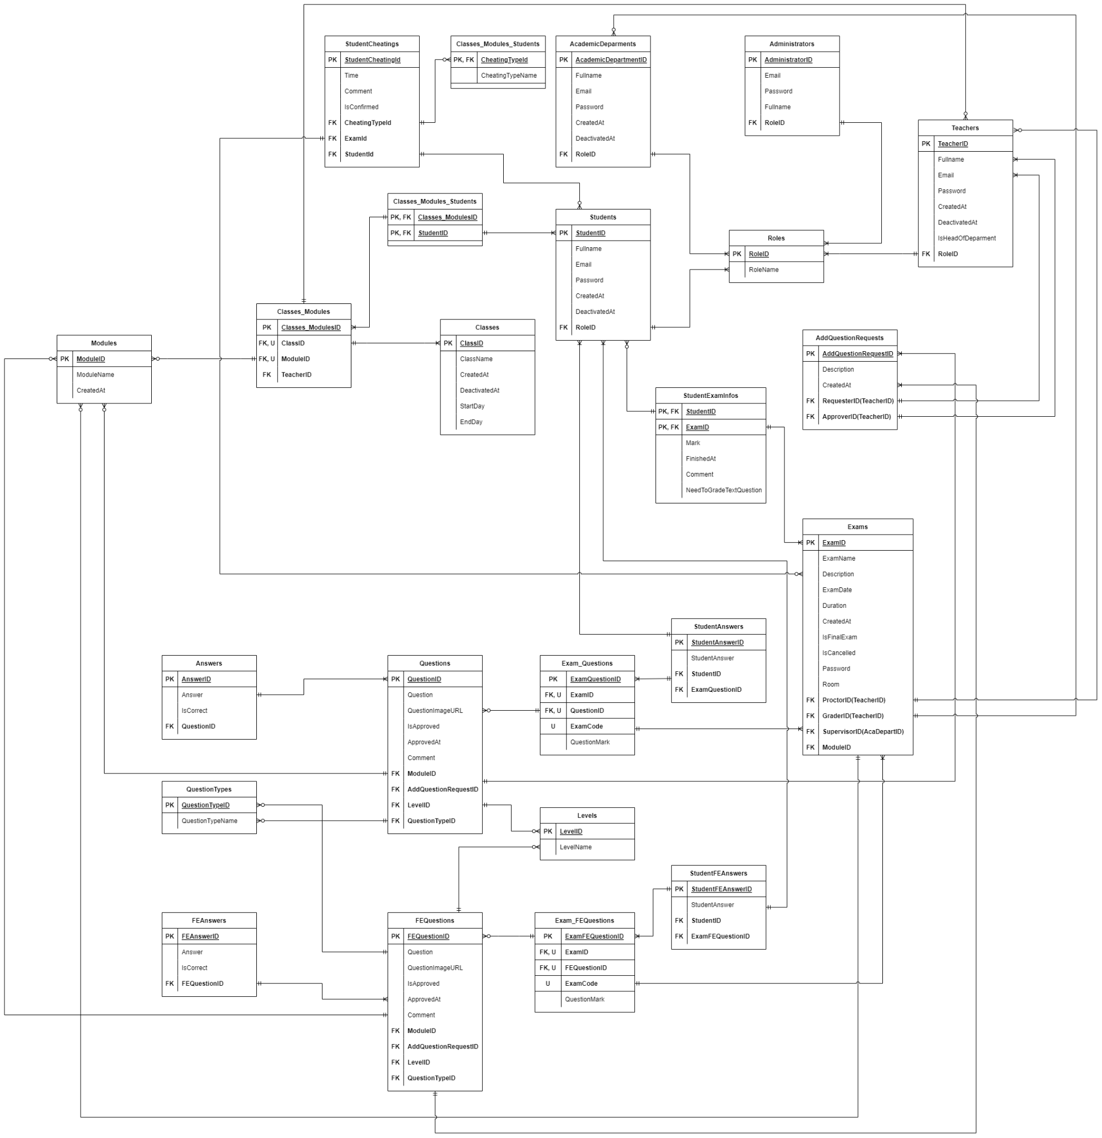
Figure 41 Database Design Diagram

a. AcademicDeparment Table
# | Field name | Type | Size | Unique | Not Null | PK/FK | Notes
1 | AcademicDepartmentId | SERIAL |  | ✓ | ✓ | PK
2 | Fullname | TEXT
3 | Email | TEXT
4 | Password | TEXT
5 | CreatedAt | TIMESTAMP |  |  | ✓
6 | DeactivatedAt | TIMESTAMP
7 | RoleId | INTEGER |  |  | ✓ | FK

b. AddQuestionRequest Table
# | Field name | Type | Size | Unique | Not Null | PK/FK | Notes
1 | AddQuestionRequestId | SERIAL |  | ✓ | ✓ | PK
2 | Description | TEXT
3 | CreatedAt | TIMESTAMP
4 | RequesterId | INTEGER |  |  | ✓ | FK
5 | ApproverId | INTEGER |  |  |  | FK

c. Administartor Table
# | Field name | Type | Size | Unique | Not Null | PK/FK | Notes
1 | AdministratorId | SERIAL |  |  | ✓ | PK
2 | Email | TEXT
3 | Password | TEXT
4 | Fullname | TEXT
5 | RoleId | INTEGER |  |  | ✓ | FK

d. Answer Table
# | Field name | Type | Size | Unique | Not Null | PK/FK | Notes
1 | AnswerId | SERIAL |  | ✓ | ✓ | PK
2 | QuestionId | INTEGER |  | ✓ | ✓ | FK
3 | AnswerContent | TEXT |  |  | ✓
4 | isCorrect | BOOL |  |  | ✓

e. CheatingType Table
# | Field name | Type | Size | Unique | Not Null | PK/FK | Notes
 | CheatingTypeId | INTEGER |  | ✓ | ✓ | PK
 | CheatingTypeName | TEXT |  | ✓ | ✓

f. ClassModuleStudent Table
# | Field name | Type | Size | Unique | Not Null | PK/FK | Notes
1 | Classes_ModuleId | INTEGER |  |  | ✓ | PK, FK
2 | StudentId | INTEGER |  |  | ✓ | PK, FK

g. Class Table
# | Field name | Type | Size | Unique | Not Null | PK/FK | Notes
1 | ClassId | INTEGER |  | ✓ | ✓ | PK
2 | ClassName | TEXT |  |  | ✓
3 | CreatedAt | TIMESTAMP |  |  | ✓
4 | StartDay | TIMESTAMP |  |  | ✓
5 | EndDay | TIMESTAMP |  |  | ✓
6 | DeactivatedAt | TIMESTAMP

h. ClassModule Table
# | Field name | Type | Size | Unique | Not Null | PK/FK | Notes
1 | ClassModuleId | SERIAL |  | ✓ | ✓ | PK
2 | ClassId | INTEGER |  | ✓ | ✓ | FK
3 | ModuleId | INTEGER |  | ✓ | ✓ | FK
4 | TeacherId | INTEGER |  |  | ✓ | FK

i. ExamFEQuestion Table
# | Field name | Type | Size | Unique | Not Null | PK/FK | Notes
1 | ExamFEQuestionId | SERIAL |  | ✓ | ✓ | PK
2 | ExamId | INTEGER |  | ✓ | ✓ | FK
3 | FEQuestionId | INTEGER |  | ✓ | ✓ | FK
4 | ExamCode | INTEGER |  | ✓ | ✓
5 | QuestionMark | REAL |  |  | ✓

j. Exam Table
# | Field name | Type | Size | Unique | Not Null | PK/FK | Notes
1 | ExamId | SERIAL |  |  | ✓ | PK
2 | ExamName | TEXT
3 | Description | TEXT
4 | ExamDay | TIMESTAMP |  |  | ✓
5 | DurationInMinute | INTEGER |  |  | ✓
6 | CreatedAt | TIMESTAMP |  |  | ✓
7 | IsFinalExam | BOOL |  |  | ✓
8 | IsCancelled | BOOL |  |  | ✓
9 | Password | TEXT
10 | Room | TEXT
11 | ProctorId | INTEGER |  |  | ✓ | FK
12 | GraderId | INTEGER |  |  | ✓ | FK
13 | SupervisorId | INTEGER |  |  | ✓ | FK
14 | ModuleId | INTEGER |  |  | ✓ | FK

k. ExamQuestion Table
# | Field name | Type | Size | Unique | Not Null | PK/FK | Notes
1 | ExamQuestionId | SERIAL |  | ✓ | ✓ | PK
2 | ExamId | INTEGER |  | ✓ | ✓ | FK
3 | QuestionId | INTEGER |  | ✓ | ✓ | FK
4 | ExamCode | INTEGER |  | ✓ | ✓
5 | QuestionMark | REAL |  |  | ✓

m. FEAnswer Table
# | Field name | Type | Size | Unique | Not Null | PK/FK | Notes
1 | FEAnswerId | INTEGER |  | ✓ | ✓ | PK
2 | FEQuestionId | INTEGER |  | ✓ | ✓ | FK
3 | AnswerContent | TEXT |  |  | ✓
4 | isCorrect | BOOL |  |  | ✓

m. FEQuestion Table
# | Field name | Type | Size | Unique | Not Null | PK/FK | Notes
1 | FEQuestionId | SERIAL |  | ✓ | ✓ | PK
2 | QuestionContent | TEXT
3 | QuestionImageURL | TEXT
4 | isApproved | BOOL
5 | ApproveAt | TIMESTAMP
6 | LevelId | INTEGER |  |  | ✓ | FK
7 | ModuleId | INTEGER |  |  | ✓ | FK
8 | QuestionTypeId | INTEGER |  |  | ✓ | FK
9 | AddQuestionRequestId | INTEGER |  |  | ✓ | FK

n. Level Table
# | Field name | Type | Size | Unique | Not Null | PK/FK | Notes
1 | LevelId | INTEGER |  | ✓ | ✓ | PK
2 | LevelName | TEXT |  |  | ✓

o. Module Table
# | Field name | Type | Size | Unique | Not Null | PK/FK | Notes
1 | ModuleId | SERIAL |  |  | ✓ | PK
2 | ModuleName | TEXT
3 | CreatedAt | TIMESTAMP |  |  | ✓
4 | ModuleCode | TEXT |  | ✓

p. Question Table
# | Field name | Type | Size | Unique | Not Null | PK/FK | Notes
1 | QuestionID | SERIAL |  |  | ✓ | PK
2 | QuestionContent | TEXT
3 | QuestionImageURL | TEXT
4 | ApproveAt | TIMESTAMP
5 | Comment | TEXT
6 | LevelId | INTEGER |  |  | ✓ | FK
7 | ModuleId | INTEGER |  |  | ✓ | FK
8 | QuestionTypeId | INTEGER |  |  | ✓ | FK
9 | AddQuestionRequestId | INTEGER |  |  | ✓ | FK
10 | isApproved | BOOL

q. QuestionType Table
# | Field name | Type | Size | Unique | Not Null | PK/FK | Notes
1 | QuestionTypeId | SERIAL |  |  | ✓ | PK
2 | QuestionTypeName | TEXT

r. Role Table
# | Field name | Type | Size | Unique | Not Null | PK/FK | Notes
1 | RoleId | INTEGER |  | ✓ | ✓ | PK
2 | RoleName | TEXT |  |  | ✓

s. Student Table
# | Field name | Type | Size | Unique | Not Null | PK/FK | Notes
1 | StudentId | INTEGER |  | ✓ | ✓ | PK
2 | Email | TEXT |  | ✓ | ✓
3 | Password | TEXT |  |  | ✓
4 | Fullname | TEXT |  |  | ✓
5 | CreatedAt | TIMESTAMP |  |  | ✓
6 | DeactivatedAt | TIMESTAMP
7 | RoleId | INTEGER |  |  | ✓ | FK
8 | ClassId | INTEGER |  |  | ✓ | FK

t. StudentAnswer Table
# | Field name | Type | Size | Unique | Not Null | PK/FK | Notes
1 | StudentAnswerId | SERIAL |  | ✓ | ✓ | PK
2 | StudentAnswerContent | TEXT
3 | ExamQuestionId | INTEGER |  |  | ✓ | FK
4 | StudentId | INTEGER |  |  | ✓ | FK

u. StudentCheating Table
# | Field name | Type | Size | Unique | Not Null | PK/FK | Notes
1 | StudentCheatingId | INTEGER |  | ✓ | ✓ | PK
2 | ExamId | INTEGER |  |  | ✓ | FK
3 | StudentId | INTEGER |  |  | ✓ | FK
4 | Time | TIMESTAMP |  |  | ✓
5 | Comment | TEXT
6 | IsConfirmed | BOOL |  |  | ✓
7 | CheatingTypeId | INTEGER |  |  | ✓ | FK

v. StudentExamInfos Table
# | Field name | Type | Size | Unique | Not Null | PK/FK | Notes
1 | ExamId | INTEGER |  | ✓ | ✓ | PK, FK
2 | StudentId | INTEGER |  | ✓ | ✓ | PK, FK
3 | Mark | FLOAT
4 | FinishAt | TIMESTAMP
5 | Comment | TEXT
6 | NeedToGradeTextQuestion | BOOL |  |  | ✓

w. StudentFEAnswer Table
# | Field name | Type | Size | Unique | Not Null | PK/FK | Notes
1 | StudentFEAnswerId | INTEGER |  | ✓ | ✓ | PK
2 | StudentAnswerContent | TEXT
3 | ExamFEQuestionId | INTEGER |  |  | ✓ | FK
4 | StudentId | INTEGER |  |  | ✓ | FK

x. Teachers Table
# | Field name | Type | Size | Unique | Not Null | PK/FK | Notes
1 | TeacherId | SERIAL |  | ✓ | ✓ | PK
2 | Email | TEXT |  | ✓
3 | Password | TEXT
4 | Fullname | TEXT
5 | isHeadOfDepartment | BOOL |  |  | ✓
6 | CreatedAt | TIMESTAMP |  |  | ✓
7 | DeactivatedAt | TIMESTAMP
8 | RoleId | INTEGER |  |  | ✓ | FK

Class Diagram - ViewerDiagram
Login – Google Drive
Forgot Password – Google Drive
Update Account – Google Drive
Create Module – Google Drive
Update Module – Google Drive
Delete Module – Google Drive
Create Class - Google Drive
ViewClassList(Aca).png
Update Class – Google Drive
Create Final Exam – Google Drive
Update Final Exam – Google Drive
Delete Exam – Google Drive
Create Exam – Google Drive
Update Exam – Google Drive
Delete Exam – Google Drive
ExportModuleExamResult - Google Drive
Create exam paper – Google Drive
GradeWrittenQuestion.png
View all requests add question bank – Google Drive
Request add new question to question bank – Google Drive
Assign teacher to process add question request – Google Drive
ViewExamSchedule.png
View exam questions – Google Drive
Submit Exam – Google Drive
View module list – Google Drive
Database Design Diagram - ViewerDiagram

